 | AgroMet Advisory Bulletin (AAB)  Jointly released by  Regional Meteorology Centre, Chennai – India Meteorology Department,  Reddiarchathram Seed Growers Association &  M. S. Swaminathan Research Foundation, Kannivadi  Phone no.: 044 - 22541229 E mail: amfu.kanniwadi@gmail.com Fax: 044 – 22541319 |  |  |  |  |  | 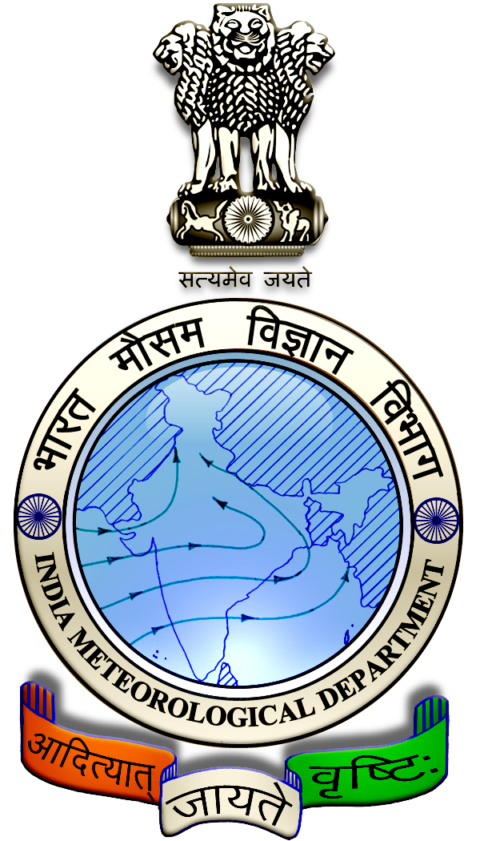
 | District : | Madurai | Forecast Period : | 03/08/2024 | to | 07/08/2024
 | Bulletine No : | MSSRF/ MDU / 062/ 2024 | Release Date : | 02/08/2024

Significant past weather | From |  | 30/07/2024 | to | 01/08/2024
Parameters |  | Past Weather
Rainfall (mm) |  | 0.5
Maximum Temperature (ºC) |  | 36-39
Minimum Temperature (ºC) |  | 25-28
Sky Condition (Octas) |  | 4-7
Relative Humidity (%) |  | 45-70
Wind Speed (kmph) |  | 9-19

Ensemble Weather Forecast until | 08:30Hrs of | 07-08-2024
Parameters | 03-08-2024 | 04-08-2024 | 05-08-2024 | 06-08-2024 | 07-08-2024
Parameters | Saturday | Sunday | Monday | Tuesday | Wednesday
Rainfall (mm) | 3 | 4 | 4 | 5 | 5
Maximum Temperature (°C) | 40 | 39 | 39 | 38 | 37
Minimum Temperature (°C) | 28 | 27 | 26 | 26 | 25
Sky Condition (Octas) | 6 | 8 | 7 | 8 | 7
Max. Relative Humidity (%) | 70 | 70 | 70 | 70 | 70
Min. Relative Humidity (%) | 40 | 50 | 50 | 40 | 40
Wind Speed (Kmph) | 6 | 4 | 6 | 6 | 6
Wind Direction | NW | NW | NW | E | SW

SMS Advisory | Chances of light rain during the next five days. Maximum temperature would be in the range of 37℃ to 40℃ and the minimum temperature would be between 25℃ - 28℃. Generally cloudy sky will appear for the next five days. Wind is expected with the speed of 4 – 6 Kmph from, Northwest, East & Southwest directions.

General Advisory:
Extended range Forecast for next week (02nd to 15th August 2024):

Rainfall:
As per extended range predictions, there is possibility of slightly above normal rainfall likely over the district during 2nd to 15th August 2024.

Maximum Temperature:
Maximum temperatures are likely to be near normal and are likely to be in the range 28°C to 32°C over the plains of the district during next week. 2nd to 15th August 2024.

Minimum Temperature:
Minimum temperatures are likely to be near normal and are likely to be in the range 18°C to 22°C over the district during next week 2nd to 8th August 2024.

Minimum temperatures are likely to be normal to slightly above normal and are likely to be in the range 20°C to 24°C over the district during next week 9thto 15th August 2024.
Agriculture:
Farmers are advised to get ready for sowing and planting of horticultural crops, such as Chillies, Brinjal, Snake gourd, Banana and other perennial crops during this season (Aadipattam).

Heavy Wind Warning:
Strong surface wind with the speed of 30 – 40 kmph is likely to occur at isolated places over the district on 03.08.24 & 04.08.24. Hence farmers are advised to provide propping in sugarcane and to provide adequate support for crops like Banana, Papaya, Guava and Moringa crops, to prevent from lodging.

For Gourds check the structures / pandhals for damages in the strings and poles and provide adequate support.

Postpone the spraying activity.

Do not allow the animals to graze outside, standing near the trees, don’t tie the animals on electric poles. Provide safe shelter for the animals.

Weather Based Agro-Advisories: (Paddy, Coconut & Animal Husbandry)
Paddy:
The incidence of Green leafhoppers noticed in Paddy fields. It affects the leaves from tip to downwards and becomes yellow in colour. Retarded vigorous and stunted growth, and drying up of the plant due to sucking up of the leaf are the other symptoms.
This can be controlled by spraying the solution of Pungam oil @ 60ml + Iluppai oil @ 60ml + Neem oil @ 60ml + Sticky agent @ 10ml (Khadi soap @ 10gms) with 10 litres of water and mixing well and spraying 2 times at 12days interval.
Also, fix light traps in the field to attract and destroy the insects.

Coconut:
Due to the prevailing weather conditions, there is a chance for the incidence of Thanjavur wilt disease in coconut crops. The spread of the disease is faster from July to November.

Initial symptoms of Thanjavur Wilt start with yellowing and drooping of the outer whorl of leaves. This is followed by the exudation of reddish brown liquid through cracks at the base of the trunk and oozing spread upwards.

Decaying of tissues at the bleeding point and rotting of the basal portion of the stem.

To control this mix and apply Pseudomonas fluorescence @ 200gm + Phosphobacter @ 200gm + Azotobacter @ 200gm with 50kg of FYM per tree.

Also, mix 5kg of Neem cake with 50kg of FYM per tree and apply it in six-month intervals.

Animal Husbandry:
Due to the prevailing weather condition, Enterotoxaemia disease may affect the Goats. The main symptom of the disease causes sudden death in young growing kids. Mucous diarrhoea may also be seen during death.

To prevent this disease, do not feed on young grass, allow the goat for grazing one hour after the sunshine.

Immediately contact the nearest veterinary clinic and vaccinate your animals.
.

