 | AgroMet Advisory Bulletin (AAB)  Jointly released by  Regional Meteorology Centre, Chennai – India Meteorology Department,  Reddiarchathram Seed Growers Association &  M. S. Swaminathan Research Foundation, Kannivadi  Phone no.: 044 - 22541229 E mail: amfu.kanniwadi@gmail.com Fax: 044 – 22541319 |  |  |  |  |  | 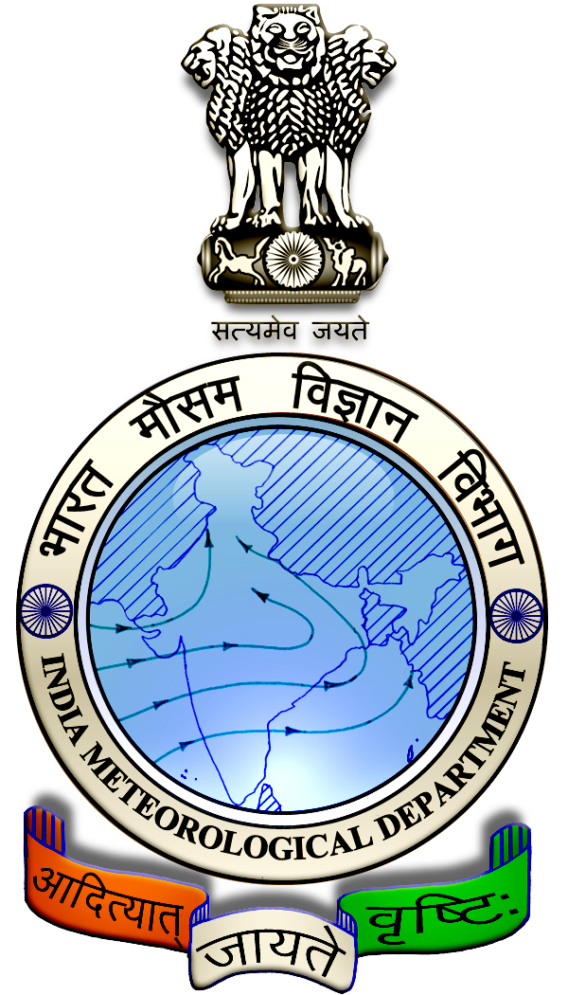
 | District : | Madurai | Forecast Period : | 07/08/2024 | to | 11/08/2024
 | Bulletine No : | MSSRF/ MDU / 063/ 2024 | Release Date : | 06/08/2024

Significant past weather | From |  | 02/08/2024 | to | 05/08/2024
Parameters |  | Past Weather
Rainfall (mm) |  | 2.9
Maximum Temperature (ºC) |  | 39-41
Minimum Temperature (ºC) |  | 25-27
Sky Condition (Octas) |  | 4-6
Relative Humidity (%) |  | 43-87
Wind Speed (kmph) |  | 5-17

Ensemble Weather Forecast until | 08:30Hrs of | 11-08-2024
Parameters | 07-08-2024 | 08-08-2024 | 09-08-2024 | 10-08-2024 | 11-08-2024
Parameters | Wednesday | Thursday | Friday | Saturday | Sunday
Rainfall (mm) | 5 | 4 | 3 | 3 | 5
Maximum Temperature (°C) | 36 | 35 | 35 | 34 | 34
Minimum Temperature (°C) | 25 | 24 | 24 | 23 | 23
Sky Condition (Octas) | 8 | 8 | 7 | 6 | 8
Max. Relative Humidity (%) | 70 | 70 | 70 | 70 | 70
Min. Relative Humidity (%) | 50 | 40 | 40 | 40 | 50
Wind Speed (Kmph) | 8 | 6 | 6 | 6 | 6
Wind Direction | NW | SW | SW | SW | S

SMS Advisory | Chances of light rain during the next five days. Maximum temperature would be in the range of 34℃ to 36℃ and the minimum temperature would be between 23℃ - 25℃. Cloudy sky will appear for the next five days. Wind is expected with the speed of 6 – 8 Kmph from, Northwest, Southwest & South directions.

General Advisory:
Extended range Forecast for next week (09th to 15th August 2024):

Rainfall:
As per extended range predictions, there is possibility of slightly above normal rainfall likely over the district during 9th to 15th August 2024.

Maximum Temperature:
Maximum temperatures are likely to be near normal and are likely to be in the range 28°C to 32°C over the plains of the district during next week. 9th to 15th August 2024.

Minimum Temperature:
Minimum temperatures are likely to be normal to slightly above normal and are likely to be in the range 20°C to 24°C over the district during next week 9thto 15th August 2024.

Heavy Wind Warning:
Strong surface wind with the speed of 30 – 40 kmph is likely to occur at isolated places over the district on 07.08.24 & 08.08.24. Hence farmers are advised to provide propping in sugarcane and to provide adequate support for crops like Banana, Papaya, Guava and Moringa crops, to prevent from lodging.

For Gourds check the structures / pandhals for damages in the strings and poles and provide adequate support.

Postpone the spraying activity.

Do not allow the animals to graze outside, standing near the trees, don’t tie the animals on electric poles. Provide safe shelter for the animals.

Weather Based Agro-Advisories: (Paddy, Guava & Animal Husbandry)
Paddy:
The incidence of Paddy Leaf folder expected in Paddy crop, the symptoms are leaves folding longitudinally and larvae remaining inside. Larvae scrap the green tissue of the leaves and become white and dry. During a severe infestation, the whole field exhibits a scorched appearance.

To control this, tie Trichogramma egg parasitoid cards @ 5cc per acre, thrice at the 37th, 44th, and 51st days after transplanting.

Avoid excessive application of urea.

Install Light trap at 1No. per acre.

Spray NSKE @ 5ml per litre of water or Spray Chlorpyrifos 20 EC @ 5ml per litre of water.

Spraying activities can be done during the non-rainy days.

Guava:
Micronutrient deficiency is noticed in Guava fruit crops, due to this, the leaves become smaller, the spacing between the nodes decreases, the plants look like shrubs, the leaves turn pale and the edges look wilted.

The spraying of micronutrients controls the bronzing of leaves. A combined spray should be given containing ZnSo4, MgSo4, MnSo4 @ 25gms, Borax @ 50gms and CuSO4 and FeSO4 @ 25grams with sticky agent @ 10ml per 10 litres of water.

Spray four times, once when new shoots appear and second, a month later, third and fourth times during the flowering and fruiting stages.

Animal Husbandry:
Light to Moderate rain with thunderstorm and lightning is likely to occur at isolated places over district on 7 & 8 August. Keep your Livestock / Animals safely in the shelters. Don’t tie the animals to the electric poles and under trees.

To safeguard your animals from lightning and thunderstorm, remove the metal bells tied to the necks of animals.
.

