 | AgroMet Advisory Bulletin (AAB)  Jointly released by  Regional Meteorology Centre, Chennai – India Meteorology Department,  Reddiarchathram Seed Growers Association &  M. S. Swaminathan Research Foundation, Kannivadi  Phone no.: 044 - 22541229 E mail: amfu.kanniwadi@gmail.com Fax: 044 – 22541319 |  |  |  |  |  | 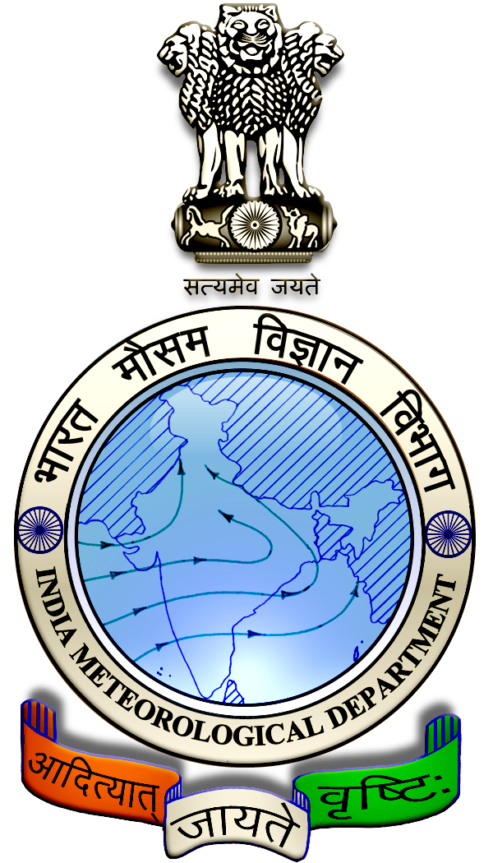
 | District : | Madurai | Forecast Period : | 24/08/2024 | to | 28/08/2024
 | Bulletine No : | MSSRF/ MDU / 068/ 2024 | Release Date : | 23/08/2024

Significant past weather | From |  | 20/08/2024 | to | 22/08/2024
Parameters |  | Past Weather
Rainfall (mm) |  | 31.0
Maximum Temperature (ºC) |  | 34-35
Minimum Temperature (ºC) |  | 25
Sky Condition (Octas) |  | 6-7
Relative Humidity (%) |  | 60-86
Wind Speed (kmph) |  | 4-11

Ensemble Weather Forecast until | 08:30Hrs of | 28-08-2024
Parameters | 24-08-2024 | 25-08-2024 | 26-08-2024 | 27-08-2024 | 28-08-2024
Parameters | Saturday | Sunday | Monday | Tuesday | Wednesday
Rainfall (mm) | 2 | 1 | 2 | 2 | 2
Maximum Temperature (°C) | 35 | 36 | 36 | 37 | 37
Minimum Temperature (°C) | 26 | 26 | 27 | 27 | 27
Sky Condition (Octas) | 6 | 4 | 5 | 5 | 4
Max. Relative Humidity (%) | 70 | 70 | 70 | 70 | 70
Min. Relative Humidity (%) | 40 | 40 | 40 | 40 | 40
Wind Speed (Kmph) | 14 | 14 | 14 | 12 | 12
Wind Direction | SW | SW | W | W | W

SMS Advisory | Chances of very light rain during 24, 25, 26, 27 & 28 Aug. Maximum temperature would be in the range of 35℃ to 37℃ and the minimum temperature would be between 26℃ - 27℃. Generally cloudy sky will appear for the next five days. Wind is expected with the speed of 12 – 14 Kmph from, Southwest & West directions.

General Advisory:
Agriculture:
Sucking pest infestation may be prevalent in vegetables, pulses and groundnut crops. Hence, 5% Neem seed kernel extract may be sprayed to control the pest incidence

Livestock:
Light to Moderate rain with thunderstorm & lightning is likely to occur at isolated places over the district on 24 & 25 August 2024. Farmers are advised to take precautionary measures while grazing/ herding the sheep, goat, cow on agriculture land for manuring purpose. Do not allow the animals to graze outside, standing near the trees or electric poles. Provide safe shelter for your livestock.

Weather Based Agro-Advisories: (Paddy, Jasmine & Animal Husbandry)
Paddy:
The incidence of Green leafhoppers noticed in Paddy fields. It affects the leaves from tip to downwards and becomes yellow in colour. Retarded vigorous and stunted growth, and drying up of the plant due to sucking up of the leaf are the other symptoms.
This can be controlled by spraying the solution of Pungam oil @ 60ml + Iluppai oil @ 60ml + Neem oil @ 60ml + Sticky agent @ 10ml (Khadi soap @ 10gms) with 10 litres of water and mixing well and spraying 2 times at 12days interval.

Also, fix light traps in the field to attract and destroy the insects.

Jasmine:
The incense of Budworm may be noticed in Jasmine. The budworm caterpillar makes the hole in the flower bud and feeds on the inner content. Petals are eaten by larvae.

Collect and destroy the damaged buds with larvae. Use a light trap to attract and kill the adult moths.

Spray Neem Seed Kernel Extract (NSKE) @ 5% (ie., 50gm dry seeds powder per litre of water + 2gm detergent soap). Always use freshly prepared NSKE.

Spray the extract in the evening hours (after 3:30 Pm) to get effective results.

The Jasmine bushes should be pruned properly and the fields should be maintained cleanly.

Animal Husbandry:
Goat-rearing farmers should protect their goats against tapeworms, which can cause mortality and weight loss.

De-worm your goats between July and September. If you haven’t done so yet, contact your local veterinarian immediately to obtain de-worming medication.

