 | AgroMet Advisory Bulletin (AAB)  Jointly released by  Regional Meteorology Centre, Chennai – India Meteorology Department,  Reddiarchathram Seed Growers Association &  M. S. Swaminathan Research Foundation, Kannivadi  Phone no.: 044 - 22541229 E mail: amfu.kanniwadi@gmail.com Fax: 044 – 22541319 |  |  |  |  |  | 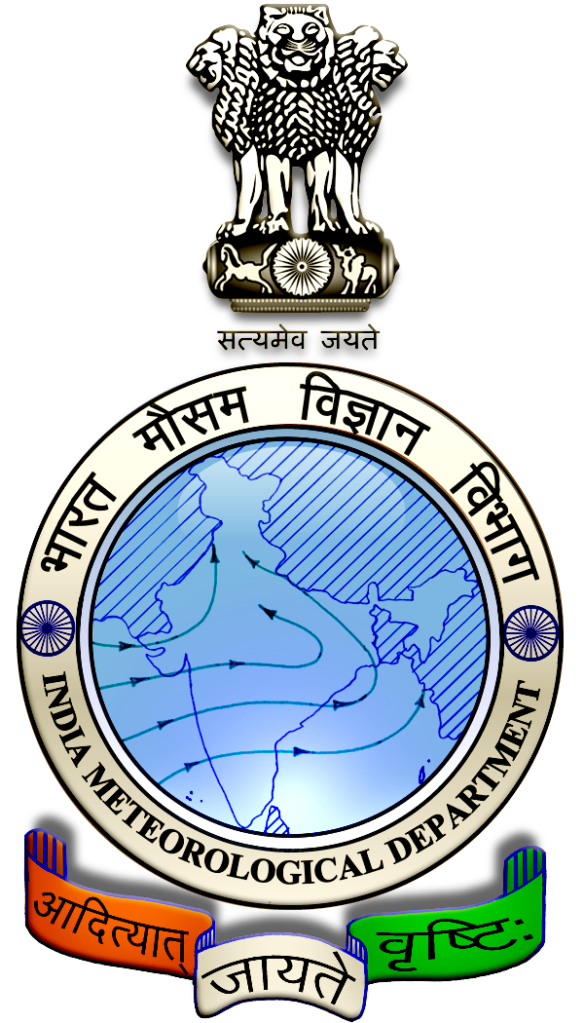
 | District : | Madurai | Forecast Period : | 28/08/2024 | to | 01/09/2024
 | Bulletine No : | MSSRF/ MDU / 069/ 2024 | Release Date : | 27/08/2024

Significant past weather | From |  | 23/08/2024 | to | 26/08/2024
Parameters |  | Past Weather
Rainfall (mm) |  | 1.5
Maximum Temperature (ºC) |  | 35-38
Minimum Temperature (ºC) |  | 24-26
Sky Condition (Octas) |  | 4-6
Relative Humidity (%) |  | 39-88
Wind Speed (kmph) |  | 9-17

Ensemble Weather Forecast until | 08:30Hrs of | 01-09-2024
Parameters | 28-08-2024 | 29-08-2024 | 30-08-2024 | 31-08-2024 | 01-09-2024
Parameters | Wednesday | Thursday | Friday | Saturday | Sunday
Rainfall (mm) | 1 | 1 | 0 | 2 | 0
Maximum Temperature (°C) | 39 | 38 | 38 | 37 | 37
Minimum Temperature (°C) | 26 | 25 | 24 | 24 | 23
Sky Condition (Octas) | 8 | 8 | 8 | 7 | 8
Max. Relative Humidity (%) | 70 | 70 | 70 | 70 | 70
Min. Relative Humidity (%) | 40 | 50 | 50 | 50 | 50
Wind Speed (Kmph) | 6 | 10 | 12 | 10 | 8
Wind Direction | NW | SW | SW | W | W

SMS Advisory | Chances of very light rain during 28, 29 & 31 Aug. Maximum temperature would be in the range of 37℃ to 39℃ and the minimum temperature would be between 23℃ - 26℃. Cloudy sky will appear for the next five days. Wind is expected with the speed of 6 – 12 Kmph from, Northwest, Southwest & West directions.

General Advisory:
Agriculture:
As the temperature is expected to increase in the forthcoming days, sucking pest infestation may be prevalent in vegetables, pulses and groundnut crops. Hence, 5% Neem seed kernel extract may be sprayed to control the pest incidence.

Livestock:
Light to Moderate rain with thunderstorm & lightning is likely to occur at isolated places over the district during 28, 29 & 30 August 2024. Farmers are advised to take precautionary measures while grazing/ 5herding the sheep, goat, cow on agriculture land for manuring purpose. Do not allow the animals to graze outside, standing near the trees or electric poles. Provide safe shelter for your livestock.

Weather Based Agro-Advisories: (Paddy, Crossandra & Animal Husbandry)
Paddy:
The incense of Bacterial Leaf Blight may be noticed in the paddy during the 3rd to 4th week of planting. The symptoms are seedling wilt. Lesions turn yellow to white as the disease advances.

To avoid this, treat the seeds with the bio-input Pseudomonas mixed with rice gruel.

Spray any one of the following, (starting from the initial appearance of the disease and another one at a fortnight interval) Neem oil 60 EC @ 3% (or) NSKE @ 5% (or) fresh cow dung extract @ 20% twice to control the sheath rot, sheath blight, grain discolouration and bacterial blight.

Plant protection activities can be done, only on non-rainy days.

Crossandra:

The infestation of the nematode was noticed in Crossandra floral crop.

The symptoms are stunted parches in the field, yellowing with puckering symptoms, internodal length reduced to give a rosette appearance, and lesions on the secondary and tertiary roots.

To control, apply Paecilomyces Lilacinus W.P @ 2kg/acre, apply FYM @ 12 ½ tonne/ha and apply neem cake @ 500 kg/ha.

Animal Husbandry:
Despite the fact that green fodder is abundantly available during the rainy season and also there are more chances for consumption of green fodder by cattle.

This is due to the fact that an increase in consumption of green fodder can lead to the occurrence of green diarrhoea and a problem of Acidosis.

Ensure that the fodder given to animals is mixed with larger quantities of dry fodder at this time.

