 | AgroMet Advisory Bulletin (AAB)  Jointly released by  Regional Meteorology Centre, Chennai – India Meteorology Department,  Reddiarchathram Seed Growers Association &  M. S. Swaminathan Research Foundation, Kannivadi  Phone no.: 044 - 22541229 E mail: amfu.kanniwadi@gmail.com Fax: 044 – 22541319 |  |  |  |  |  | 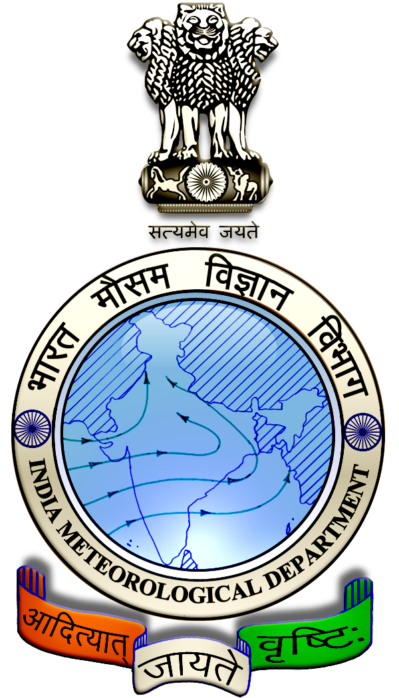
 | District : | Pudukkottai | Forecast Period : | 03/08/2024 | to | 07/08/2024
 | Bulletin No: | MSSRF/ PDK /062/ 2024 | Release Date : | 02/08/2024

Significant past weather | From |  | 30/07/2024 | to | 01/08/2024
Parameters |  | Past Weather
Rainfall (mm) |  | 0.0
Maximum Temperature (ºC) |  | 37
Minimum Temperature (ºC) |  | 26-27
Sky Condition (Octas) |  | 5-7
Relative Humidity (%) |  | 42-71
Wind Speed (kmph) |  | 25-28

Ensemble Weather Forecast until | 08:30Hrs of |  | 07-08-2024
Parameters | 03-08-2024 | 04-08-2024 |  | 05-08-2024 | 06-08-2024 | 07-08-2024
Parameters | Saturday | Sunday |  | Monday | Tuesday | Wednesday
Rainfall (mm) | 1 | 2 |  | 3 | 4 | 4
Maximum Temperature (°C) | 38 | 38 |  | 37 | 37 | 37
Minimum Temperature (°C) | 27 | 27 |  | 26 | 26 | 26
Sky Condition (Octa) | 7 | 8 |  | 7 | 8 | 7
Max. Relative Humidity (%) | 70 | 70 |  | 70 | 70 | 70
Min. Relative Humidity (%) | 30 | 40 |  | 50 | 40 | 40
Wind Speed (Kmph) | 10 | 10 |  | 10 | 10 | 10
Wind Direction | W | NW |  | NW | S | SE

SMS Advisory | Chances of light rain during 5, 6 & 7 Aug. Maximum temperature would be in the range of 37℃ to 38℃ and the minimum temperature would be between 26℃ - 27℃. Generally cloudy sky will appear for the next five days. Wind is expected with the speed of 10 Kmph from, West, Northwest, South & Southeast directions.

General Advisory:
Extended range Forecast for next week (02nd to 15th August 2024):

Rainfall:
As per extended range predictions, there is possibility of slightly above normal rainfall likely over the district during 2nd to 15th August 2024.

Maximum Temperature:
Maximum temperatures are likely to be near normal and are likely to be in the range 32°C to 36°C over the plains of the district during next week. 2nd to 15th August 2024.

Minimum Temperature:
Minimum temperatures are likely to be near normal and are likely to be in the range 22°C to 26°C over the district during next week 2nd to 8th August 2024.

Minimum temperatures are likely to be normal to slightly above normal and are likely to be in the range 24°C to 28°C over the district during next week 9thto 15th August 2024.

Agriculture:
Farmers are advised to get ready for sowing and planting of horticultural crops, such as Chillies, Brinjal, Snake gourd, Banana and other perennial crops during this season (Aadipattam).

Heavy Wind Warning:
Strong surface wind with the speed of 30 – 40 kmph is likely to occur at isolated places over the district on 03.08.24 & 04.08.24. Hence farmers are advised to provide propping in sugarcane and to provide adequate support for crops like Banana, Papaya, Guava and Moringa crops, to prevent from lodging.

For Gourds check the structures / pandhals for damages in the strings and poles and provide adequate support.

Postpone the spraying activity.

Do not allow the animals to graze outside, standing near the trees, don’t tie the animals on electric poles. Provide safe shelter for the animals.

Weather Based Agro-Advisories: (Blackgram, Maize & Animal Husbandry)
Blackgram:
Spraying of the micronutrient is important for the Blackgram crop. Foliar spray of NAA 40mg/litre and Salicylic acid 100 mg/litre once at pre-flowering and another at 15 days later.
For rice fallow crops, foliar spray of DAP 20gm/litre once at flowering and another at 15 days later.
For irrigated and rain-fed crops, foliar spray of DAP 20gm/litre or Urea 20 gm/litre once at flowering and another at 15 days later.
Spraying activities can be done during the non-rainy days.

Maize:
The farmers who cultivated maize in Vaikasi pattam were advised to give a foliar spray of TNAU Maize Maxim @ 3 kg/acre in 200 litres of water, at tassel initiation and at grain filling stages. This will improve grain filling, increase grain yield and also build drought tolerance capacity.
Spraying activities can be done during the non-rainy days.

Animal Husbandry:
Due to the prevailing weather condition, Enterotoxaemia disease may affect the Goats. The main symptom of the disease causes sudden death in young growing kids. Mucous diarrhoea may also be seen during death.

To prevent this disease, do not feed on young grass, allow the goat for grazing one hour after the sunshine.

Immediately contact the nearest veterinary clinic and vaccinate your animals.

