 | AgroMet Advisory Bulletin (AAB)  Jointly released by  Regional Meteorology Centre, Chennai – India Meteorology Department,  Reddiarchathram Seed Growers Association &  M. S. Swaminathan Research Foundation, Kannivadi  Phone no.: 044 - 22541229 E mail: amfu.kanniwadi@gmail.com Fax: 044 – 22541319 |  |  |  |  |  | 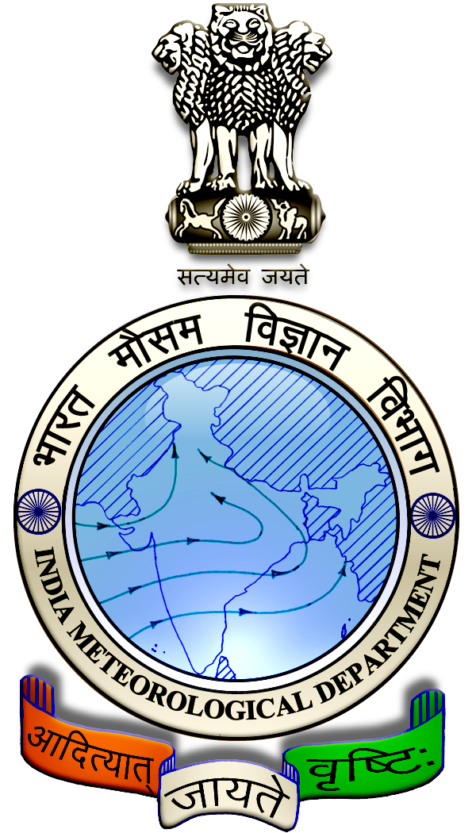
 | District : | Pudukkottai | Forecast Period : | 24/08/2024 | to | 28/08/2024
 | Bulletin No: | MSSRF/ PDK /068/ 2024 | Release Date : | 23/08/2024

Significant past weather | From |  | 20/08/2024 | to | 22/08/2024
Parameters |  | Past Weather
Rainfall (mm) |  | 14.4
Maximum Temperature (ºC) |  | 35-36
Minimum Temperature (ºC) |  | 24-26
Sky Condition (Octas) |  | 6-7
Relative Humidity (%) |  | 59-85
Wind Speed (kmph) |  | 10-17

Ensemble Weather Forecast until | 08:30Hrs of |  | 28-08-2024
Parameters | 24-08-2024 | 25-08-2024 |  | 26-08-2024 | 27-08-2024 | 28-08-2024
Parameters | Saturday | Sunday |  | Monday | Tuesday | Wednesday
Rainfall (mm) | 0 | 0 |  | 0 | 0 | 1
Maximum Temperature (°C) | 36 | 36 |  | 37 | 36 | 37
Minimum Temperature (°C) | 26 | 26 |  | 27 | 27 | 27
Sky Condition (Octa) | 8 | 4 |  | 5 | 5 | 6
Max. Relative Humidity (%) | 70 | 70 |  | 70 | 60 | 60
Min. Relative Humidity (%) | 40 | 40 |  | 40 | 40 | 40
Wind Speed (Kmph) | 16 | 12 |  | 10 | 12 | 12
Wind Direction | SW | SW |  | SW | SW | SW

SMS Advisory | Chances of very light rain on 28 Aug. Maximum temperature would be in the range of 36℃ to 37℃ and the minimum temperature would be between 26℃ - 27℃. Generally cloudy sky will appear for the next five days. Wind is expected with the speed of 10 – 16 Kmph from, Southwest direction.

General Advisory:

Agriculture:
Sucking pest infestation may be prevalent in vegetables, pulses and groundnut crops. Hence, 5% Neem seed kernel extract may be sprayed to control the pest incidence.

Wind with the speed of 10 to 16 kmph is expected for the next five days. Hence farmers are advised to provide propping in sugarcane and to provide adequate support for crops like Banana, Papaya, Guava and Moringa, to prevent from lodging. For Gourds check the structures /pandhals for damages in the strings and poles and provide adequate support. Postpone the spraying activity.

Weather Based Agro-Advisories: (Paddy, Cotton & Animal Husbandry)
Paddy:
In river-irrigated regions where rice is typically grown, during anticipated water shortages, it is advisable to plant pulse crops instead of short-duration rice to conserve water. Alternatively, the dry-seeded rice method can be employed.

Cotton:
In Cotton cultivation, this is the suitable time for Seed pelleting.

Seeds can be coated with Arappu leaf powder 100g/kg along with DAP 40g/kg, micronutrient mixture 15g/kg and Azospirillum 200g/kg using 500ml Maida solution or gruel as adhesive (300 ml/kg) to increase the germination and vigour.

Dibble the seeds at a depth of 3-5 cm on the side of the ridge.

Animal Husbandry:
Goat-rearing farmers should protect their goats against tapeworms, which can cause mortality and weight loss.

De-worm your goats between July and September. If you haven’t done so yet, contact your local veterinarian immediately to obtain de-worming medication.

