 | AgroMet Advisory Bulletin (AAB)  Jointly released by  Regional Meteorology Centre, Chennai – India Meteorology Department,  Reddiarchathram Seed Growers Association &  M. S. Swaminathan Research Foundation, Kannivadi  Phone no.: 044 - 22541229 E mail: amfu.kanniwadi@gmail.com Fax: 044 – 22541319 |  |  |  |  |  | 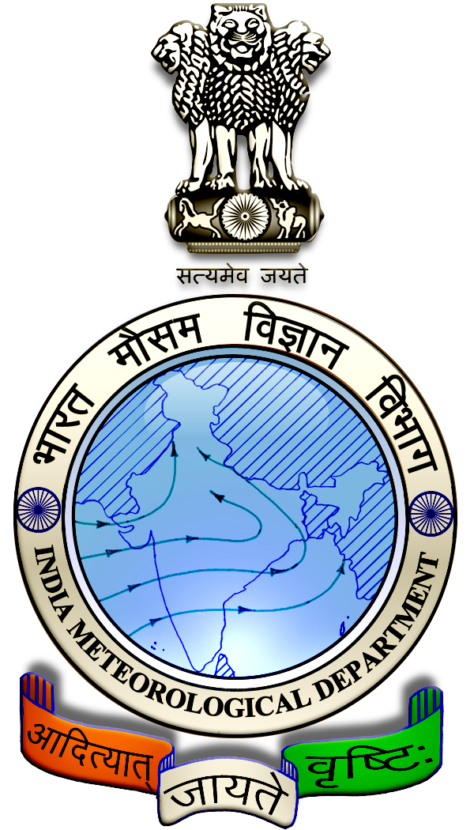
 | District : | Ramanathapuram | Forecast Period : | 24/08/2024 | to | 28/08/2024
 | Bulletin No: | MSSRF/ RMD /068/ 2024 | Release Date : | 23/08/2024

Significant past weather | From |  | 20/08/2024 | to | 22/08/2024
Parameters |  | Past Weather
Rainfall (mm) |  | 4.4
Maximum Temperature (ºC) |  | 33-34
Minimum Temperature (ºC) |  | 25-26
Sky Condition (Octas) |  | 5-8
Relative Humidity (%) |  | 67-78
Wind Speed (kmph) |  | 10-12

Ensemble Weather Forecast until | 08:30Hrs of |  | 28-08-2024
Parameters | 24-08-2024 | 25-08-2024 |  | 26-08-2024 | 27-08-2024 | 28-08-2024
Parameters | Saturday | Sunday |  | Monday | Tuesday | Wednesday
Rainfall (mm) | 0 | 0 |  | 0 | 0 | 0
Maximum Temperature (°C) | 35 | 36 |  | 36 | 36 | 36
Minimum Temperature (°C) | 25 | 26 |  | 26 | 26 | 26
Sky Condition (Octa) | 5 | 6 |  | 4 | 5 | 5
Max. Relative Humidity (%) | 70 | 60 |  | 60 | 60 | 70
Min. Relative Humidity (%) | 50 | 40 |  | 40 | 50 | 40
Wind Speed (Kmph) | 28 | 26 |  | 26 | 24 | 24
Wind Direction | SW | SW |  | SW | SW | SW

SMS Advisory | For the next five days, Maximum temperature would be in the range of 35℃ to 36℃ and the minimum temperature would be between 25℃ - 26℃. Generally cloudy sky will appear for the next five days. Wind is expected with the speed of 24 – 28 Kmph from, Southwest direction.

General Advisory:

Agriculture:
Sucking pest infestation may be prevalent in vegetables, pulses and groundnut crops. Hence, 5% Neem seed kernel extract may be sprayed to control the pest incidence.

Wind with the speed of 24 to 28 kmph is expected for the next five days. Hence farmers are advised to provide propping in sugarcane and to provide adequate support for crops like Banana, Papaya, Guava and Moringa, to prevent from lodging. For Gourds check the structures /pandhals for damages in the strings and poles and provide adequate support. Postpone the spraying activity.

Weather Based Agro-Advisories: (Tomato, Cotton & Animal Husbandry)
Tomato:
The incidence of Bacterial leaf spot disease in Tomato growing areas likely to occur.

To control this spraying with a combination of copper and organic fungicides in a regular preventative spray program at 5 to 10 day intervals or spraying with Agrimycin-100 (100 ppm) or Copper hydroxide at fortnight intervals is recommended for effective disease control.

Cotton:
The application of micronutrients will rectify the nutrient deficiency in Cotton.

Apply 5kg of Cotton nutrient mixture or 10 kg of Mg So₄ /acre.

Also mix 2kg of Azospirillum, and 2kg of Phosphobacteria with FYM/acre and apply it in the field.
Farmers cultivating cotton in rain-fed areas can take advantage of the current rainfall and provide 5 kg of cotton micronutrient or 20 kg of Magnesium Sulphate fertilizer per acre within 10 days of planting to address the micronutrient deficiency.
Animal Husbandry:
Goat-rearing farmers should protect their goats against tapeworms, which can cause mortality and weight loss.

De-worm your goats between July and September. If you haven’t done so yet, contact your local veterinarian immediately to obtain de-worming medication.

