 | AgroMet Advisory Bulletin (AAB)  Jointly released by  Regional Meteorology Centre, Chennai – India Meteorology Department,  Reddiarchathram Seed Growers Association &  M. S. Swaminathan Research Foundation, Kannivadi  Phone no.: 044 - 22541229 E mail: amfu.kanniwadi@gmail.com Fax: 044 – 22541319 |  |  |  |  |  | 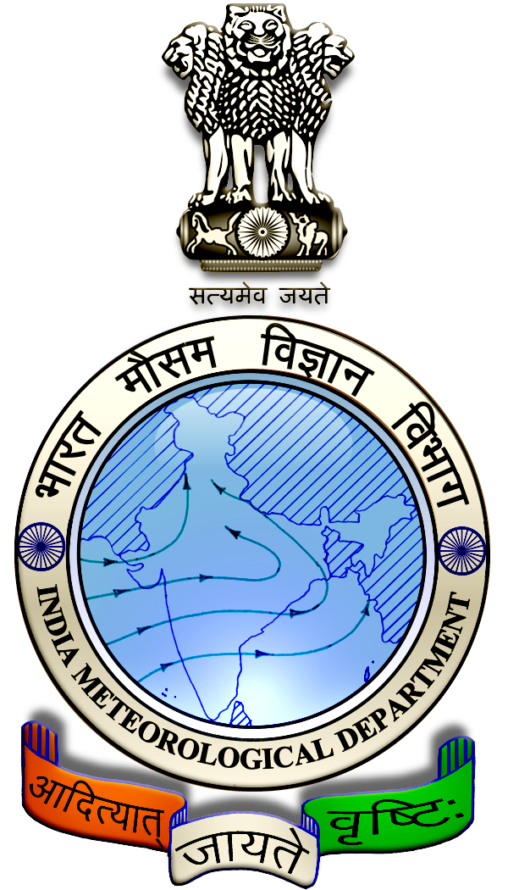
 | District : | Sivagangai | Forecast Period : | 10/08/2024 | to | 14/08/2024
 | Bulletine No : | MSSRF/SVG / 064/ 2024 | Release Date : | 09/08/2024

Significant past weather | From |  | 06/08/2024 | to | 08/08/2024
Parameters |  | Past Weather
Rainfall (mm) |  | 38.1
Maximum Temperature (ºC) |  | 36-39
Minimum Temperature (ºC) |  | 25
Sky Condition (Octas) |  | 5-8
Relative Humidity (%) |  | 63-88
Wind Speed (kmph) |  | 6-15

Ensemble Weather Forecast until | 08:30Hrs of | 14-08-2024
Parameters | 10-08-2024 | 11-08-2024 | 12-08-2024 | 13-08-2024 | 14-08-2024
Parameters | Saturday | Sunday | Monday | Tuesday | Wednesday
Rainfall (mm) | 1 | 5 | 29 | 25 | 5
Maximum Temperature (°C) | 36 | 35 | 34 | 33 | 32
Minimum Temperature (°C) | 25 | 24 | 22 | 21 | 20
Sky Condition (Octas) | 7 | 8 | 8 | 8 | 8
Max. Relative Humidity (%) | 70 | 70 | 80 | 90 | 80
Min. Relative Humidity (%) | 50 | 50 | 50 | 50 | 50
Wind Speed (Kmph) | 12 | 10 | 10 | 10 | 12
Wind Direction | SW | SE | SE | SW | SE

SMS Advisory | Chances of light rain on 11, 14 Aug & Moderate rain on 12, 13 Aug. Maximum temperature would be in the range of 32℃ to 36℃ and the minimum temperature would be between 20℃ - 25℃. Cloudy sky will appear for the next five days. Wind is expected with the speed of 10 – 12 Kmph from, Southwest & Southeast directions.

General Advisory:
Extended range Forecast for next week (09th to 22nd August 2024):

Rainfall:
As per extended range predictions, there is possibility of above normal rainfall likely over the district during 9th to 22nd August 2024.

Maximum Temperature:
Maximum temperatures are likely to be slightly above normal and are likely to be in the range 28°C to 32°C over the plains of the district during next week. 9th to 15th August 2024.

Maximum temperatures are likely to be generally near normal and are likely to be in the range 28°C to 32°C over the plains of the district during next week. 16th to 22nd August 2024

Minimum Temperature:
Minimum temperatures are likely to be generally normal to slightly above normal and are likely to be in the range 20°C to 24°C over the district during next week 9th to 22nd August 2024.

Heavy Wind Warning:
Strong gusty wind with the speed of 30 – 40 kmph is likely to occur at isolated places over the district during 10.08.24 to 14.08.24. Hence farmers are advised to provide propping in sugarcane and to provide adequate support for crops like Banana, Papaya, Guava and Moringa crops, to prevent from lodging.

For Gourds check the structures / pandhals for damages in the strings and poles and provide adequate support.

Postpone the spraying activity.

Do not allow the animals to graze outside, standing near the trees, don’t tie the animals on electric poles. Provide safe shelter for the animals.

Heavy rain is likely to occur at isolated places over the district on 12 & 13 August 2024. Farmers are advised to act swiftly to repair the water channels, farm ponds and other water bodies to harvest the rain water. During these days farmers are advised to avoid irrigation, intercultural operations and application of plant protection measures to the standing crops, provide adequate drainage facilities in the fields to avoid water stagnation due to heavy rainfall, do not allow the animals to grazing outside, standing near the trees or electric poles & provide safe shelter.

Feed material of poultries may be drifted due to high wind speed and hence, hang gunny bags at the borders of the shed to reduce wind speed.

Weather Based Agro-Advisories: (Bhendi, Sugarcane & Animal Husbandry)
Bhendi:
At this prevailing weather condition, a foliar spray of nutrition is essentialto increase the yield in Bhendi crop.

Spray 1% Urea (10g/litre) and a Murate of Potash (17g/litre) on 30th and 45th days after planting.

For hybrids, foliar application of water-soluble fertilizer 19-19-19 three times @ 0.5% (5g/l) at 10 daysintervals from 30 days after planting is recommended.

Sugarcane:
There is the incense of Top shoot borer in Sugarcane. The symptoms found in the emerging leaves with shot holes in parallel rows and red tunnels in the midribs of leaves, dead heart in grown-up canes which cannot be easily pulled, Dead heart reddish brown in colour, Bunchy top due to growth of side shoots. To control this release Trichogramma Chilonis @ 5cc per Acre. Apply Cartap Granule ( Green Granule) @ 7Kg per acre mixed with Farm Yard Manure @ 35kg.

Animal Husbandry:
Light to Moderate rain with thunderstorm and lightning is likely to occur at isolated places over district during 10 to 14 August 2024. Keep your Livestock / Animals safely in the shelters. Don’t tie the animals to the electric poles and under trees.

To safeguard your animals from lightning and thunderstorm, remove the metal bells tied to the necks of animals.

