 | AgroMet Advisory Bulletin (AAB)  Jointly released by  Regional Meteorology Centre, Chennai – India Meteorology Department,  Reddiarchathram Seed Growers Association &  M. S. Swaminathan Research Foundation, Kannivadi  Phone no.: 044 - 22541229 E mail: amfu.kanniwadi@gmail.com Fax: 044 – 22541319 |  |  |  |  |  | 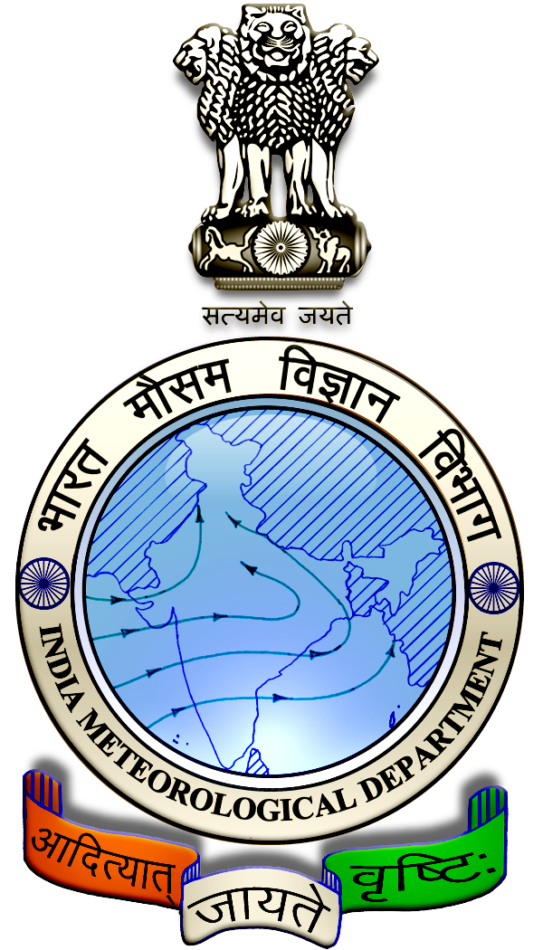
 | District : | Sivagangai | Forecast Period : | 24/08/2024 | to | 28/08/2024
 | Bulletine No : | MSSRF/SVG / 068/ 2024 | Release Date : | 23/08/2024

Significant past weather | From |  | 20/08/2024 | to | 22/08/2024
Parameters |  | Past Weather
Rainfall (mm) |  | 43.2
Maximum Temperature (ºC) |  | 34-35
Minimum Temperature (ºC) |  | 25
Sky Condition (Octas) |  | 6-7
Relative Humidity (%) |  | 60-86
Wind Speed (kmph) |  | 4-11

Ensemble Weather Forecast until | 08:30Hrs of | 28-08-2024
Parameters | 24-08-2024 | 25-08-2024 | 26-08-2024 | 27-08-2024 | 28-08-2024
Parameters | Saturday | Sunday | Monday | Tuesday | Wednesday
Rainfall (mm) | 0 | 0 | 0 | 0 | 0
Maximum Temperature (°C) | 35 | 36 | 36 | 37 | 37
Minimum Temperature (°C) | 26 | 26 | 27 | 27 | 27
Sky Condition (Octas) | 6 | 4 | 5 | 5 | 4
Max. Relative Humidity (%) | 70 | 70 | 70 | 70 | 70
Min. Relative Humidity (%) | 40 | 40 | 40 | 40 | 40
Wind Speed (Kmph) | 20 | 18 | 18 | 14 | 14
Wind Direction | SW | SW | SW | SW | SW

SMS Advisory | For the next five days, Maximum temperature would be in the range of 35℃ to 37℃ and the minimum temperature would be between 26℃ - 27℃. Generally cloudy sky will appear for the next five days. Wind is expected with the speed of 14 – 20 Kmph from, Southwest direction.

General Advisory:
Agriculture:
Sucking pest infestation may be prevalent in vegetables, pulses and groundnut crops. Hence, 5% Neem seed kernel extract may be sprayed to control the pest incidence.

Wind with the speed of 14 to 20 kmph is expected for the next five days. Hence farmers are advised to provide propping in sugarcane and to provide adequate support for crops like Banana, Papaya, Guava and Moringa, to prevent from lodging. For Gourds check the structures /pandhals for damages in the strings and poles and provide adequate support. Postpone the spraying activity.

Weather Based Agro-Advisories: (Chilly, Paddy & Animal Husbandry)
Chilly:
The incense of Chilly Thrips is noticed in Chilly fields. The infected leaves develop crinkles and curl upwards. Elongated petiole, buds become brittle and drop down.
Early-stage, infestation leads to stunted growth and flower production, and fruit sets get arrested.
To avoid this, intercrop with Agathi crop (Sesbania grandiflora) to provide shade which regulates the Thrips population.
Sprinkle water over the seedlings to check the multiplication of Thrips.
Spray the insecticide Imidacloprid 17.8% SL @ 3ml/10 litres of water.

Paddy:
Since farmers are waiting for rainfall and planning for sowing/planting, for the paddy nursery raised in the low nutrient soil, it is best to apply the DAP to the seedlings, 10 days before transplanting. Transplanting within 10days will give good results.

Animal Husbandry:
Goat-rearing farmers should protect their goats against tapeworms, which can cause mortality and weight loss.

De-worm your goats between July and September. If you haven’t done so yet, contact your local veterinarian immediately to obtain de-worming medication.

