 | AgroMet Advisory Bulletin (AAB)  Jointly released by  Regional Meteorology Centre, Chennai – India Meteorology Department,  Reddiarchathram Seed Growers Association &  M. S. Swaminathan Research Foundation, Kannivadi  Phone no.: 044 - 22541229 E mail: amfu.kanniwadi@gmail.com Fax: 044 – 22541319 |  |  |  |  |  | 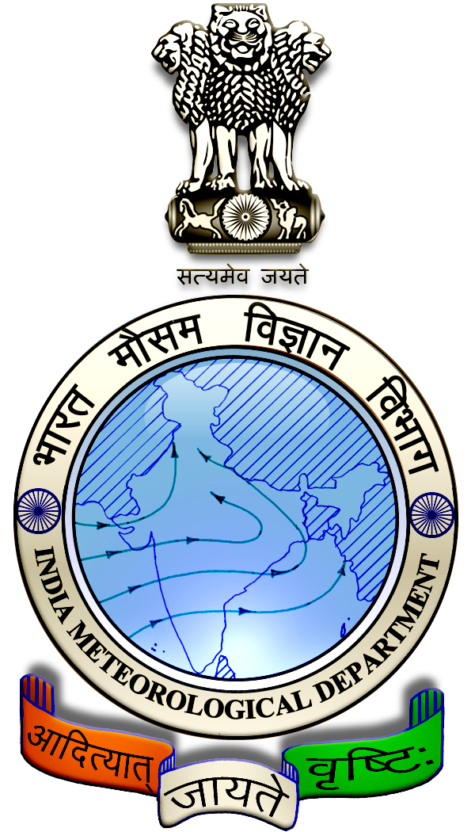
 | District : | Sivagangai | Forecast Period : | 28/08/2024 | to | 01/09/2024
 | Bulletine No : | MSSRF/SVG / 069/ 2024 | Release Date : | 27/08/2024

Significant past weather | From |  | 23/08/2024 | to | 26/08/2024
Parameters |  | Past Weather
Rainfall (mm) |  | 0.0
Maximum Temperature (ºC) |  | 35-38
Minimum Temperature (ºC) |  | 24-26
Sky Condition (Octas) |  | 4-6
Relative Humidity (%) |  | 39-88
Wind Speed (kmph) |  | 9-17

Ensemble Weather Forecast until | 08:30Hrs of | 01-09-2024
Parameters | 28-08-2024 | 29-08-2024 | 30-08-2024 | 31-08-2024 | 01-09-2024
Parameters | Wednesday | Thursday | Friday | Saturday | Sunday
Rainfall (mm) | 1 | 4 | 0 | 3 | 0
Maximum Temperature (°C) | 39 | 38 | 38 | 37 | 37
Minimum Temperature (°C) | 26 | 25 | 24 | 24 | 23
Sky Condition (Octas) | 8 | 8 | 8 | 7 | 8
Max. Relative Humidity (%) | 70 | 70 | 70 | 70 | 70
Min. Relative Humidity (%) | 40 | 50 | 50 | 50 | 50
Wind Speed (Kmph) | 10 | 12 | 16 | 10 | 10
Wind Direction | SE | SW | SW | W | SW

SMS Advisory | Chances of light rain on 29 & 31 Aug. Maximum temperature would be in the range of 37℃ to 39℃ and the minimum temperature would be between 23℃ - 26℃. Cloudy sky will appear for the next five days. Wind is expected with the speed of 10 – 16 Kmph from, Southeast, Southwest & West directions.

General Advisory:
Agriculture:
As the temperature is expected to increase in the forthcoming days, sucking pest infestation may be prevalent in vegetables, pulses and groundnut crops. Hence, 5% Neem seed kernel extract may be sprayed to control the pest incidence.

Wind with the speed of 10 to 16 kmph is expected for the next five days. Hence farmers are advised to provide propping in sugarcane and to provide adequate support for crops like Banana, Papaya, Guava and Moringa, to prevent from lodging. For Gourds check the structures /pandhals for damages in the strings and poles and provide adequate support. Postpone the spraying activity.

Livestock:
Light to Moderate rain with thunderstorm & lightning is likely to occur at isolated places over the district during 28, 29 & 30 August 2024. Farmers are advised to take precautionary measures while grazing/ 5herding the sheep, goat, cow on agriculture land for manuring purpose. Do not allow the animals to graze outside, standing near the trees or electric poles. Provide safe shelter for your livestock
Weather Based Agro-Advisories: (Banana, Brinjal & Animal Husbandry)
Banana:
The incidence of pseudo stem borer is expected in Banana. The symptom of damage appears in the stem.

Grub bores into the pseudo stem making tunnels, tunnelled part decomposes and a blackened mass comes out from the bore hole.

To control, spray Chlorantraniliprole @ 10ml + Sticky agent 10ml with 10 litres of water.

Brinjal:
Farmers are advised to monitor the whitefly in the Brinjal field.

To manage this, fix the yellow sticky trap at 5 Nos. per acre.

And Spray the mixture of 3ml Neem oil with 1ml Teepol (Sticky agent) per litre of water.

Animal Husbandry:
Despite the fact that green fodder is abundantly available during the rainy season and also there are more chances for consumption of green fodder by cattle.

This is due to the fact that an increase in consumption of green fodder can lead to the occurrence of green diarrhoea and a problem of Acidosis.

Ensure that the fodder given to animals is mixed with larger quantities of dry fodder at this time.

