 | AgroMet Advisory Bulletin (AAB)  Jointly released by  Regional Meteorology Centre, Chennai – India Meteorology Department,  Reddiarchathram Seed Growers Association &  M. S. Swaminathan Research Foundation, Kannivadi  Phone no.: 044 - 22541229 E mail: amfu.kanniwadi@gmail.com Fax: 044 – 22541319 |  |  |  |  |  | 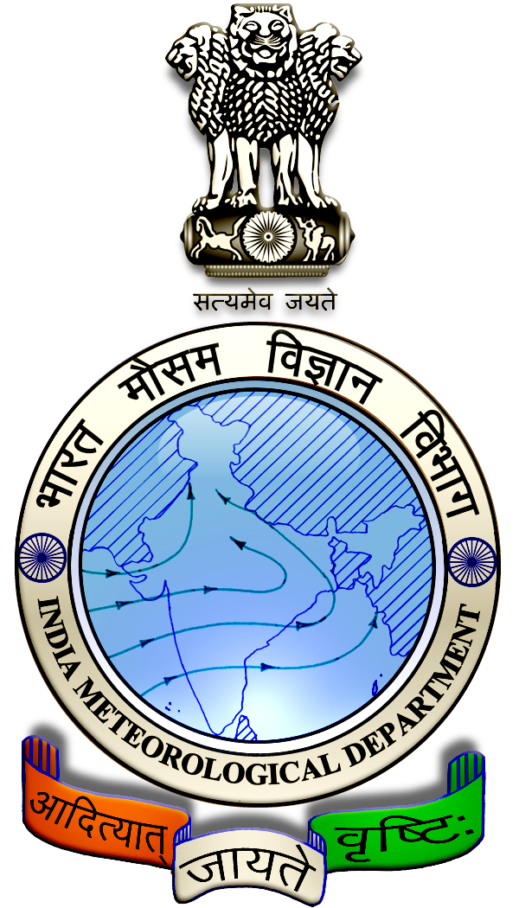
 | District : | Theni | Forecast Period : | 07/08/2024 | to | 11/08/2024
 | Bulletine No : | MSSRF/ THN/ 063/ 2024 | Release Date : | 06/08/2024

Significant past weather | From |  | 02/08/2024 | to | 05/08/2024
Parameters |  | Past Weather
Rainfall (mm) |  | 2.5
Maximum Temperature (ºC) |  | 39-41
Minimum Temperature (ºC) |  | 25-27
Sky Condition (Octas) |  | 4-6
Relative Humidity (%) |  | 43-87
Wind Speed (kmph) |  | 5-17

Ensemble Weather Forecast until | 08:30Hrs of | 11-08-2024
Parameters | 07-08-2024 | 08-08-2024 | 09-08-2024 | 10-08-2024 | 11-08-2024
Parameters | Wednesday | Thursday | Friday | Saturday | Sunday
Rainfall (mm) | 7 | 6 | 2 | 4 | 7
Maximum Temperature (°C) | 33 | 32 | 32 | 31 | 31
Minimum Temperature (°C) | 23 | 22 | 22 | 21 | 21
Sky Condition (Octas) | 8 | 8 | 8 | 6 | 8
Max. Relative Humidity (%) | 80 | 70 | 70 | 80 | 80
Min. Relative Humidity (%) | 50 | 40 | 40 | 50 | 50
Wind Speed (Kmph) | 12 | 10 | 10 | 8 | 6
Wind Direction | W | NW | W | W | W

SMS Advisory | Chances of light rain during the next five days. Maximum temperature would be in the range of 31℃ to 33℃ and the minimum temperature would be between 21℃ - 23℃. Cloudy sky will appear for the next five days. Wind is expected with the speed of 6 – 12 Kmph from, West & Northwest directions.

General Advisory:
Extended range Forecast for next week (09th to 15th August 2024):

Rainfall:
As per extended range predictions, there is possibility of slightly above normal rainfall likely over the district during 9th to 15th August 2024.

Maximum Temperature:
Maximum temperatures are likely to be near normal and are likely to be in the range 28°C to 32°C over the plains of the district during next week. 9th to 15th August 2024.

Minimum Temperature:
Minimum temperatures are likely to be normal to slightly above normal and are likely to be in the range 20°C to 24°C over the district during next week 9thto 15th August 2024.

Heavy Wind Warning:
Strong surface wind with the speed of 30 – 40 kmph is likely to occur at isolated places over the district on 07.08.24 & 08.08.24. Hence farmers are advised to provide propping in sugarcane and to provide adequate support for crops like Banana, Papaya, Guava and Moringa crops, to prevent from lodging.

For Gourds check the structures / pandhals for damages in the strings and poles and provide adequate support.

Postpone the spraying activity.

Do not allow the animals to graze outside, standing near the trees, don’t tie the animals on electric poles. Provide safe shelter for the animals.

Weather Based Agro-Advisories: (Banana, Banana & Animal Husbandry)
Onion:
Farmers involved in the sowing of small onions are advised to apply Zinc sulphate @ 10 kg, Copper sulphate @ 1Kg & Manganese sulphate @ 10kg along with farmyard manure @ 210 kg/acre as basal dose.

Banana:
The incense of Rhizome weevil was noticed in the Banana. It grubs bore into the rhizome and caused the death of the plant.

The presence of dark-coloured tunnels is seen in the rhizomes. Death of unopened pipe and withering of outer leaves are the other symptoms.

Apply castor cake 250g per pit before planting which prevents infestation.

Soil incorporation at the time of planting with 60-100g of Neem kernel powder or Neem cake.

Animal Husbandry:
Light to Moderate rain with thunderstorm and lightning is likely to occur at isolated places over district on 7 & 8 August. Keep your Livestock / Animals safely in the shelters. Don’t tie the animals to the electric poles and under trees.

To safeguard your animals from lightning and thunderstorm, remove the metal bells tied to the necks of animals.

