 | AgroMet Advisory Bulletin (AAB)  Jointly released by  Regional Meteorology Centre, Chennai – India Meteorology Department,  Reddiarchathram Seed Growers Association &  M. S. Swaminathan Research Foundation, Kannivadi  Phone no.: 044 - 22541229 E mail: amfu.kanniwadi@gmail.com Fax: 044 – 22541319 |  |  |  |  |  | 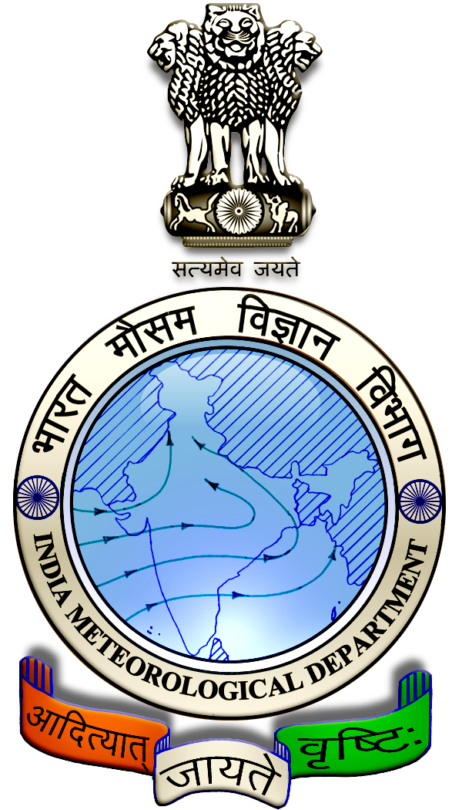
 | District : | Theni | Forecast Period : | 14/08/2024 | to | 18/08/2024
 | Bulletine No : | MSSRF/ THN/ 065/ 2024 | Release Date : | 13/08/2024

Significant past weather | From |  | 09/08/2024 | to | 12/08/2024
Parameters |  | Past Weather
Rainfall (mm) |  | 34.1
Maximum Temperature (ºC) |  | 34-37
Minimum Temperature (ºC) |  | 24-25
Sky Condition (Octas) |  | 5-7
Relative Humidity (%) |  | 53-90
Wind Speed (kmph) |  | 4-11

Ensemble Weather Forecast until | 08:30Hrs of | 18-08-2024
Parameters | 14-08-2024 | 15-08-2024 | 16-08-2024 | 17-08-2024 | 18-08-2024
Parameters | Wednesday | Thursday | Friday | Saturday | Sunday
Rainfall (mm) | 29 | 26 | 12 | 6 | 28
Maximum Temperature (°C) | 32 | 31 | 30 | 30 | 29
Minimum Temperature (°C) | 21 | 19 | 18 | 18 | 17
Sky Condition (Octas) | 8 | 8 | 8 | 8 | 8
Max. Relative Humidity (%) | 80 | 80 | 80 | 80 | 80
Min. Relative Humidity (%) | 50 | 50 | 50 | 50 | 50
Wind Speed (Kmph) | 6 | 8 | 12 | 6 | 6
Wind Direction | NW | W | W | W | NE

SMS Advisory | Chances of Moderate rain during 14, 15, 16 & 18 Aug. Maximum temperature would be in the range of 29℃ to 32℃ and the minimum temperature would be between 17℃ - 21℃. Cloudy sky will appear for the next five days. Wind is expected with the speed of 6 – 12 Kmph from, Northwest, West & Northeast directions.

General Advisory:
Extended range Forecast for next week (16th to 22nd August 2024):

Rainfall:
As per extended range predictions, there is possibility of above normal rainfall likely over the district during 16th to 22nd August 2024.

Maximum Temperature:
Maximum temperatures are likely to be generally near normal and are likely to be in the range 28°C to 32°C over the plains of the district during next week. 16th to 22nd August 2024

Minimum Temperature:
Minimum temperatures are likely to be generally normal to slightly above normal and are likely to be in the range 20°C to 24°C over the district during next week 16th to 22nd August 2024.

Heavy rain is likely to occur at isolated places over the district during 14, 15 & 18 August 2024. Farmers are advised to act swiftly to repair the water channels, farm ponds and other water bodies to harvest the rain water. During these days farmers are advised to avoid irrigation, intercultural operations and application of plant protection measures to the standing crops, provide adequate drainage facilities in the fields to avoid water stagnation due to heavy rainfall, do not allow the animals to grazing outside, standing near the trees or electric poles & provide safe shelter.

Animal Husbandry:
Light to Moderate rain with thunderstorm and lightning is likely to occur at isolated places over district during 14 to18 August 2024. Keep your Livestock / Animals safely in the shelters. Don’t tie the animals to the electric poles and under trees.

To safeguard your animals from lightning and thunderstorm, remove the metal bells tied to the necks of animals.

Weather Based Agro-Advisories: (Onion, Brinjal & Animal Husbandry)
Onion:
Farmers planning to cultivate small onion crop are, advised to apply Zinc Sulphate @ 10 kg, Copper Sulphate @ 1Kg and Manganese Sulphate @ 10kg along with farmyard manure (FYM) @ 210 kg/acre as basal dose.

Brinjal:
Due to the prevailing weather, the incidence of spotted beetles is noticed in the Brinjal crop. The symptoms of damage are found in leaves. The beetles are scrapping of chlorophyll.

It leads to skeletonizing and drying of leaves.

To control, collect the damaged leaves with grubs, and egg masses and destroy them.

Spray Cartap hydrochloride @ 35gm per tank.

Animal Husbandry:
Farmers are advised to prevent your sheep from Foot and mouth disease (FMD), first vaccination should be given at age of 2 ½ month and the same should be continued once in every 6th month.

