 | AgroMet Advisory Bulletin (AAB)  Jointly released by  Regional Meteorology Centre, Chennai – India Meteorology Department,  Reddiarchathram Seed Growers Association &  M. S. Swaminathan Research Foundation, Kannivadi  Phone no.: 044 - 22541229 E mail: amfu.kanniwadi@gmail.com Fax: 044 – 22541319 |  |  |  |  |  | 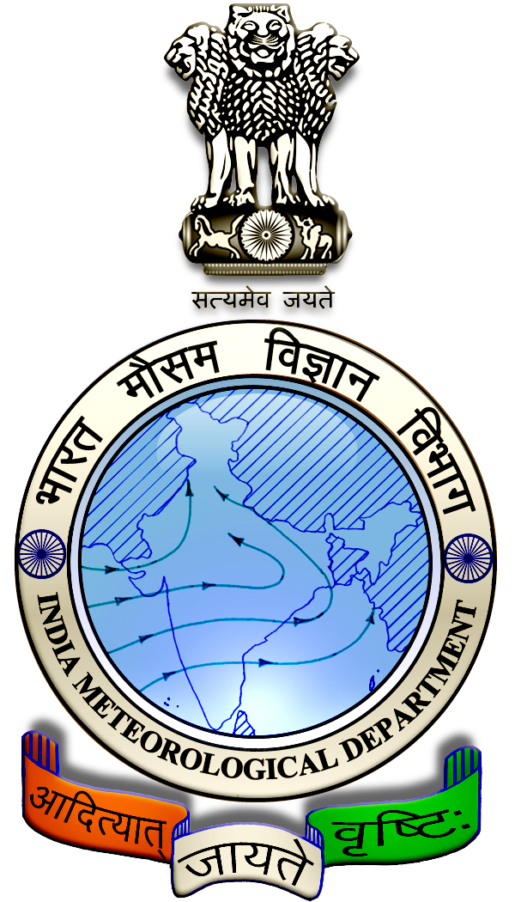
 | District : | Theni | Forecast Period : | 24/08/2024 | to | 28/08/2024
 | Bulletine No : | MSSRF/ THN/ 068/ 2024 | Release Date : | 23/08/2024

Significant past weather | From |  | 20/08/2024 | to | 22/08/2024
Parameters |  | Past Weather
Rainfall (mm) |  | 21.1
Maximum Temperature (ºC) |  | 34-35
Minimum Temperature (ºC) |  | 25
Sky Condition (Octas) |  | 6-7
Relative Humidity (%) |  | 60-86
Wind Speed (kmph) |  | 4-11

Ensemble Weather Forecast until | 08:30Hrs of | 28-08-2024
Parameters | 24-08-2024 | 25-08-2024 | 26-08-2024 | 27-08-2024 | 28-08-2024
Parameters | Saturday | Sunday | Monday | Tuesday | Wednesday
Rainfall (mm) | 2 | 2 | 2 | 2 | 2
Maximum Temperature (°C) | 32 | 32 | 31 | 31 | 31
Minimum Temperature (°C) | 22 | 21 | 21 | 21 | 22
Sky Condition (Octas) | 6 | 4 | 5 | 5 | 4
Max. Relative Humidity (%) | 70 | 70 | 70 | 70 | 70
Min. Relative Humidity (%) | 40 | 40 | 40 | 40 | 40
Wind Speed (Kmph) | 14 | 14 | 12 | 14 | 12
Wind Direction | W | W | W | W | W

SMS Advisory | Chances of very light rain during 24, 25, 26, 27 & 28 Aug. Maximum temperature would be in the range of 31℃ to 32℃ and the minimum temperature would be between 21℃ - 22℃. Generally cloudy sky will appear for the next five days. Wind is expected with the speed of 12 – 14 Kmph from, West direction.

General Advisory:
Agriculture:
Sucking pest infestation may be prevalent in vegetables, pulses and groundnut crops. Hence, 5% Neem seed kernel extract may be sprayed to control the pest incidence.

Livestock:
Light to Moderate rain with thunderstorm & lightning is likely to occur at isolated places over the district on 24 & 22 August 2024. Farmers are advised to take precautionary measures while grazing/ 5herding the sheep, goat, cow on agriculture land for manuring purpose. Do not allow the animals to graze outside, standing near the trees or electric poles. Provide safe shelter for your livestock.

Weather Based Agro-Advisories: (Paddy, Cluster beans & Animal Husbandry)
Paddy:
To reduce pest numbers and promote beneficial and neutral pests in Kurvai paddy nurseries, spray 5% neem extract during 7 to 10 days after sowing.”

Otherwise mix and spray 0.03% Azartractin at a rate of 3 grams per liter of water along with 1ml sticky agent.

Use a hand sprayer to apply the solution in the morning or evening, ensuring the nursery is thoroughly wet.”

Apply one ton of manure or compost per 20 cents per hectare while preparing the paddy nursery during the wet season.

For a kuruvai nursery, allocate an area of 20 cents to plant 1 hectare. Apply 1 ton of FYM or compost to the area.
For clay soil type, a pply 4 kg of gypsum per cent of seedlings and 1 kg of DAP on the 10th day after sowing. This helps in plucking the seedlings without damaging the roots.”

Cluster beans:
The occurrence of Aphids is noticed in Cluster beans. Nymphs and adults suck the sap of leaves. It leads to leaf wilting and flower dropping and the growth of the plants is also hindered.

To control, spray Acephate @ 40gm + sticky agent @ 10ml with 10 litres of water.

Animal Husbandry:
Goat-rearing farmers should protect their goats against tapeworms, which can cause mortality and weight loss.

De-worm your goats between July and September. If you haven’t done so yet, contact your local veterinarian immediately to obtain de-worming medication.

