 | AgroMet Advisory Bulletin (AAB)  Jointly released by  Regional Meteorology Centre, Chennai – India Meteorology Department,  Reddiarchathram Seed Growers Association &  M. S. Swaminathan Research Foundation, Kannivadi  Phone no.: 044 - 22541229 E mail: amfu.kanniwadi@gmail.com Fax: 044 – 22541319 |  |  |  |  |  | 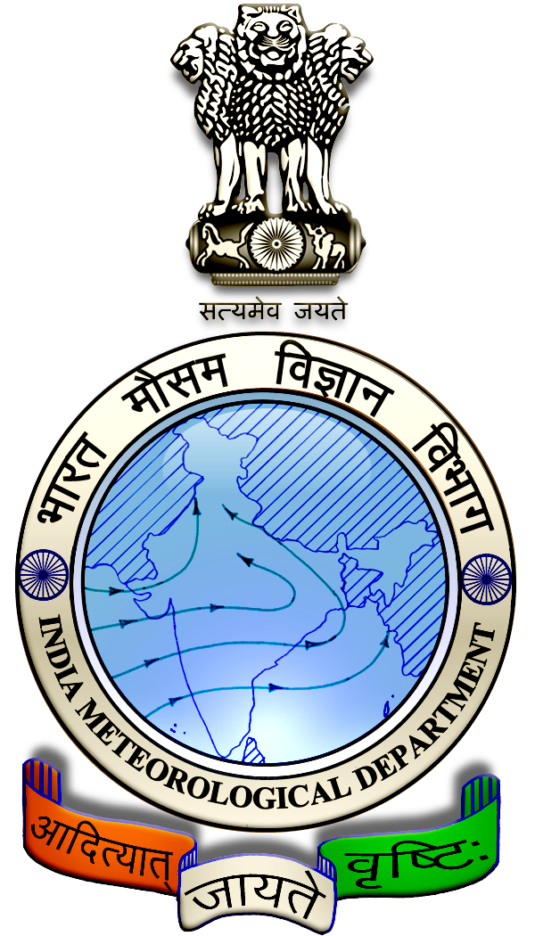
 | District : | Theni | Forecast Period : | 28/08/2024 | to | 01/09/2024
 | Bulletine No : | MSSRF/ THN/ 069/ 2024 | Release Date : | 27/08/2024

Significant past weather | From |  | 23/08/2024 | to | 26/08/2024
Parameters |  | Past Weather
Rainfall (mm) |  | 0.2
Maximum Temperature (ºC) |  | 35-38
Minimum Temperature (ºC) |  | 24-26
Sky Condition (Octas) |  | 4-6
Relative Humidity (%) |  | 39-88
Wind Speed (kmph) |  | 9-17

Ensemble Weather Forecast until | 08:30Hrs of | 01-09-2024
Parameters | 28-08-2024 | 29-08-2024 | 30-08-2024 | 31-08-2024 | 01-09-2024
Parameters | Wednesday | Thursday | Friday | Saturday | Sunday
Rainfall (mm) | 0 | 2 | 1 | 2 | 1
Maximum Temperature (°C) | 33 | 33 | 32 | 32 | 33
Minimum Temperature (°C) | 23 | 22 | 22 | 21 | 21
Sky Condition (Octas) | 6 | 6 | 5 | 7 | 8
Max. Relative Humidity (%) | 70 | 70 | 70 | 70 | 70
Min. Relative Humidity (%) | 40 | 50 | 50 | 50 | 50
Wind Speed (Kmph) | 12 | 12 | 14 | 12 | 12
Wind Direction | W | W | W | W | W

SMS Advisory | Chances of very light rain during 29, 30, 31 Aug & 1 Sep. Maximum temperature would be in the range of 32℃ to 33℃ and the minimum temperature would be between 21℃ - 23℃. Generally cloudy sky will appear for the next five days. Wind is expected with the speed of 12 – 14 Kmph from, West direction.

General Advisory:
Agriculture:
As the temperature is expected to increase in the forthcoming days, sucking pest infestation may be prevalent in vegetables, pulses and groundnut crops. Hence, 5% Neem seed kernel extract may be sprayed to control the pest incidence.

Livestock:
Light to Moderate rain with thunderstorm & lightning is likely to occur at isolated places over the district during 28, 29 & 30 August 2024. Farmers are advised to take precautionary measures while grazing/ 5herding the sheep, goat, cow on agriculture land for manuring purpose. Do not allow the animals to graze outside, standing near the trees or electric poles. Provide safe shelter for your livestock.

Weather Based Agro-Advisories: (Papaya, Chilly & Animal Husbandry)
Papaya:
The Stem rot / Foot rot is expected in papaya growing areas.
For the management of the disease, the farmers are advised to take up soil drenching around the plants with Copper Oxychloride @ 2.5g/litre.

Maintain the field with proper drainage facility.”

Chilly:
Application of Micronutrients to vegetable crops may give good results.

Farmers are advised to apply micronutrients to vegetable crops through fertigation or foliar spray during the flowering to the fruiting stage.

Animal Husbandry:
Despite the fact that green fodder is abundantly available during the rainy season and also there are more chances for consumption of green fodder by cattle.

This is due to the fact that an increase in consumption of green fodder can lead to the occurrence of green diarrhoea and a problem of Acidosis.

Ensure that the fodder given to animals is mixed with larger quantities of dry fodder at this time.

