 | AgroMet Advisory Bulletin (AAB)  Jointly released by  Regional Meteorology Centre, Chennai – India Meteorology Department,  Reddiarchathram Seed Growers Association &  M. S. Swaminathan Research Foundation, Kannivadi  Phone no.: 044 - 22541229 E mail: amfu.kanniwadi@gmail.com Fax: 044 – 22541319 |  |  |  |  |  | 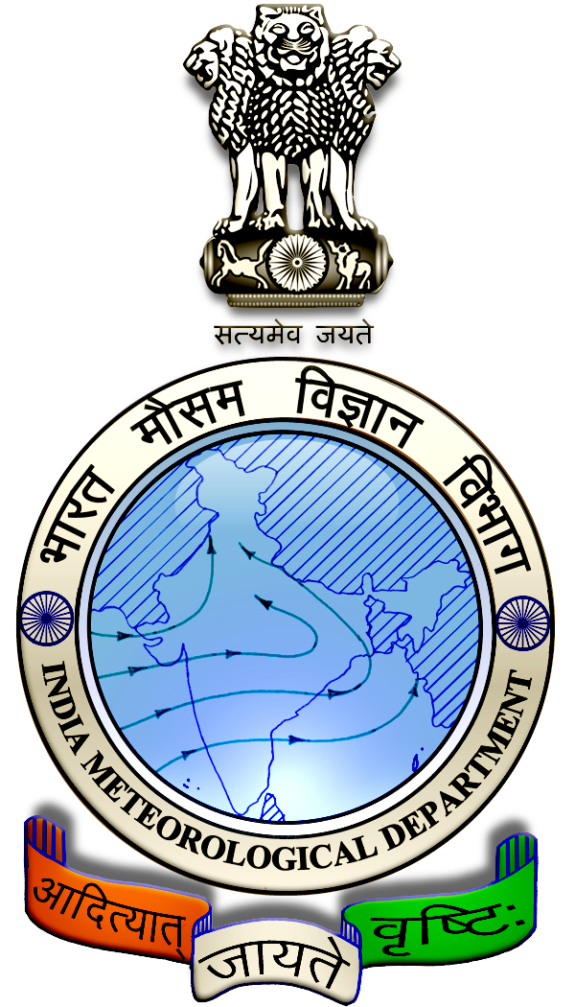
 | District : | Sivagangai | Forecast Period : | 18/12/2024 | to | 22/12/2024
 | Bulletine No : | MSSRF/SVG / 101/ 2024 | Release Date : | 17/12/2024

Significant past weather | From |  | 13/12/2024 | to | 16/12/2024
Parameters |  | Past Weather
Rainfall (mm) |  | 119.7
Maximum Temperature (ºC) |  | 24-30
Minimum Temperature (ºC) |  | 20-23
Sky Condition (Octas) |  | 2-8
Relative Humidity (%) |  | 58-94
Wind Speed (kmph) |  | 7-11

Ensemble Weather Forecast until | 08:30Hrs of | 22-12-2024
Parameters | 18-12-2024 | 19-12-2024 | 20-12-2024 | 21-12-2024 | 22-12-2024
Parameters | Wednesday | Thursday | Friday | Saturday | Sunday
Rainfall (mm) | 10 | 20 | 15 | 5 | 5
Maximum Temperature (°C) | 30 | 30 | 30 | 31 | 31
Minimum Temperature (°C) | 21 | 21 | 21 | 22 | 22
Sky Condition (Octas) | 5 | 5 | 5 | 4 | 4
Max. Relative Humidity (%) | 88 | 88 | 88 | 85 | 85
Min. Relative Humidity (%) | 50 | 50 | 50 | 53 | 53
Wind Speed (Kmph) | 10 | 10 | 10 | 8 | 8
Wind Direction | E | E | E | NE | NE

SMS Advisory | Chances of Moderate rain during 18, 19, 20 Dec & light rain on 21, 22 Dec. Maximum temperature would be in the range of 30℃ to 31℃ and the minimum temperature would be between 21℃ - 22℃. Generally cloudy sky will appear for the next five days. Wind is expected with the speed of 8-10 Kmph from, East & Northeast directions.

General Advisory:
Extended range Forecast for next week (20th to 26th December 2024):
Rainfall:
As per extended range predictions, there is possibility of near normal to slightly above normal rainfall likely over the district during 20th to 26th December 2024.

Maximum Temperature:
Maximum temperatures are likely to be slightly above normal and are likely to be in the range 26°C to 32°C over the plains of the district during next week. 20th to 26th December 2024

Minimum Temperature:
Minimum temperatures are likely to be slightly above normal and are likely to be in the range 16°C to 20°C over the district during next week 20th to 26th December 2024.

Due to the recent rains, the farmers should immediately remove the excess rainwater accumulated in the paddy fields and the lands where vegetable and horticultural crops are cultivated.

Weather Based Agro-Advisories: (Tomato, Mango & Animal Husbandry)
Tomato
The incense of Septoria Leaf Spot disease is noticed in Tomato. The plant may be attacked at any stage of its growth.

The disease is characterized by numerous, small, grey, circular leaf spots having a dark border. Remove and destroy the affected plant parts.

To control the disease effectively Spray Copper-oxychloride @ 350gm per acre in the field.

Mango:
Mango cultivating farmers are advised to adopt the following methods to plant the grafted Mango plants.
- Dig pits of 1 metre x 1 metre x 1-metre size.
- Mix 10 kg of FYM per pit with top soil and fill it up to 3/4th of the pit.
- Plant the grafts at the centre of the pit.
Water the plants immediately after planting.

Animal Husbandry:
Due to the prevailing cold weather conditions, cattle rearers are advised to allow the cattle to graze only after 2 hours of sunrise.

Cover the cow shed with gunny bags, and keep the floor in dry condition.

Dry fodder and greens should be fed without moisture to avoid fungal infection.

