 | AgroMet Advisory Bulletin (AAB)  Jointly released by  Regional Meteorology Centre, Chennai – India Meteorology Department,  Reddiarchathram Seed Growers Association &  M. S. Swaminathan Research Foundation, Kannivadi  Phone no.: 044 - 22541229 E mail: amfu.kanniwadi@gmail.com Fax: 044 – 22541319 |  |  |  |  |  | 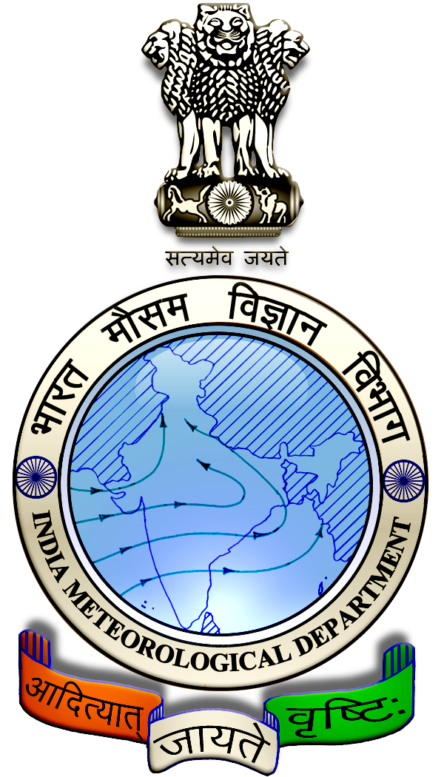
 | District : | Madurai | Forecast Period : | 06/07/2024 | to | 10/07/2024
 | Bulletine No : | MSSRF/ MDU / 054/ 2024 | Release Date : | 05/07/2024

Significant past weather | From |  | 02/07/2024 | to | 04/07/2024
Parameters |  | Past Weather
Rainfall (mm) |  | 0.0
Maximum Temperature (ºC) |  | 37-40
Minimum Temperature (ºC) |  | 26-27
Sky Condition (Octas) |  | 3-6
Relative Humidity (%) |  | 41-62
Wind Speed (kmph) |  | 7-11

Ensemble Weather Forecast until | 08:30Hrs of | 10-07-2024
Parameters | 06-07-2024 | 07-07-2024 | 08-07-2024 | 09-07-2024 | 10-07-2024
Parameters | Saturday | Sunday | Monday | Tuesday | Wednesday
Rainfall (mm) | 4 | 2 | 5 | 3 | 2
Maximum Temperature (°C) | 39 | 38 | 37 | 37 | 36
Minimum Temperature (°C) | 27 | 26 | 26 | 25 | 25
Sky Condition (Octas) | 8 | 6 | 8 | 6 | 7
Max. Relative Humidity (%) | 70 | 70 | 70 | 70 | 70
Min. Relative Humidity (%) | 50 | 50 | 50 | 50 | 40
Wind Speed (Kmph) | 8 | 10 | 10 | 10 | 10
Wind Direction | W | W | W | NW | NW

SMS Advisory | Chances of light rain during 6, 7, 8, 9 & 10 July. Maximum temperature would be in the range of 36℃ to 39℃ and the minimum temperature would be between 25℃ - 27℃. Generally cloudy sky will appear for the next five days. Wind is expected with the speed of 8-10 Kmph from, West & Northwest directions.

General Advisory:
Extended range Forecast for next week (05th to 18th July 2024):

Rainfall:
As per extended range predictions, there is possibility of near normal to slightly above normal rainfall likely over the district during 5th to 11th July 2024.

As per extended range predictions, there is possibility of generally near normal rainfall likely over the district during 12th to 18th July 2024.

Maximum Temperature:
Maximum temperatures are likely to be near normal and are likely to be in the range 28°C to 32°C over the plains of the district during next week. 05th to 11th July 2024.

Maximum temperatures are likely to be generally normal and are likely to be in the range 26°C to 32°C over the plains of the district during next week. 12th to 18th July 2024.

Minimum Temperature:
Minimum temperatures are likely to be near normal and are likely to be in the range 20°C to 24°C over the district during next week 05th to 18th July 2024.

Agriculture:
Farmers cultivating sugarcane and vegetables crops in rain-fed lands should provide rows and furrows at regular intervals and irrigate through furrows.

Irrigation water is economical as it is moistened only in the furrow area. Rain water drains easily if it gets stagnant in furrows.

In times of water scarcity, water can be saved by irrigating it with furrows. Intercropping is easy as the crops are arranged in rows.

Weather Based Agro-Advisories: (Maize, Paddy & Animal Husbandry)
Maize:
The incidence of Corn worms/earworms is expected in Maize. The symptoms appear on grains and Larva feeds on silk and developing grains.
To manage this, set up pheromone traps at 12 Nos./hectare. Also, set up a light trap @ 1No./acre in the field to attract and kill the moths and insects.
Mix Pungam Oil @ 50ml + Iluppai Oil @ 50ml + Neem Oil @ 50ml + Sticky agent @ 10ml with 10 litres of water and spray 2 times at 12 days intervals.

Paddy:
It is time to carry out the land preparation of Paddy cultivation for a good return. Ploughing should be carried out. After inundation puddling is to be done as per transplanting.

More care should be taken to level the field to zero level. Stagnation of water in patches during germination and early establishment of the crop leads to uneven crop stand. Land levelling has to say over efficient weed and water management practices.

Provision of shallow trenches (15cm width) at an interval of 3m all along the field will facilitate the draining of excess water at the early growth stage.

Animal Husbandry:
Farmers are advised to feed greens and straw to the milking cow in 50:50 ratios, as half quantity in the morning and half in the evening after milking.

Do not change the fodder and its quantity, it can be changed gradually.

Long and hard stem fodders should be cut into small pieces before feeding the Cow.

Better to feed the cow with a mixture of young foliage and dry grass with hay.

Silage should be given after the milking. Concentrate feeds should be given in the morning and evening hours with equal distribution.
.

