 | AgroMet Advisory Bulletin (AAB)  Jointly released by  Regional Meteorology Centre, Chennai – India Meteorology Department,  Reddiarchathram Seed Growers Association &  M. S. Swaminathan Research Foundation, Kannivadi  Phone no.: 044 - 22541229 E mail: amfu.kanniwadi@gmail.com Fax: 044 – 22541319 |  |  |  |  |  | 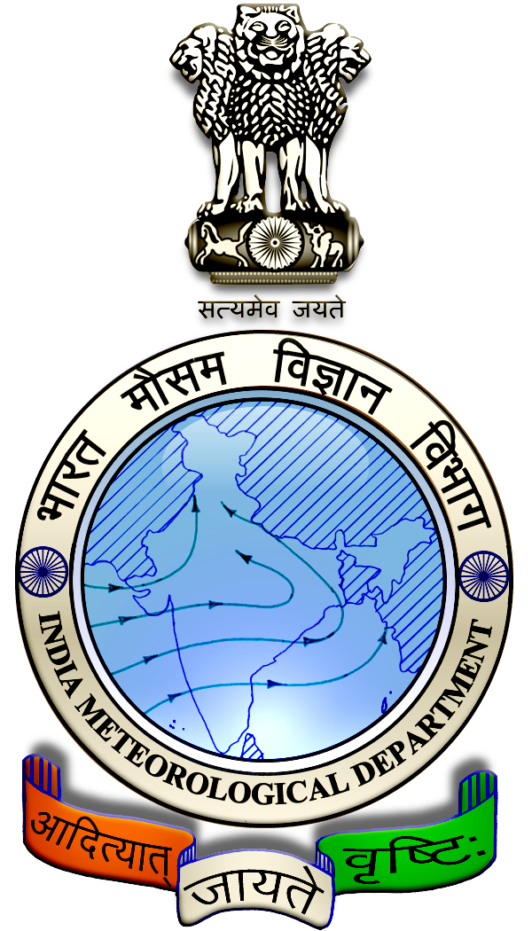
 | District : | Ramanathapuram | Forecast Period : | 06/07/2024 | to | 10/07/2024
 | Bulletin No: | MSSRF/ RMD /054/ 2024 | Release Date : | 05/07/2024

Significant past weather | From |  | 02/07/2024 | to | 04/07/2024
Parameters |  | Past Weather
Rainfall (mm) |  | 0.0
Maximum Temperature (ºC) |  | 34-35
Minimum Temperature (ºC) |  | 25-26
Sky Condition (Octas) |  | 4-5
Relative Humidity (%) |  | 72-84
Wind Speed (kmph) |  | 2-9

Ensemble Weather Forecast until | 08:30Hrs of |  | 10-07-2024
Parameters | 06-07-2024 | 07-07-2024 |  | 08-07-2024 | 09-07-2024 | 10-07-2024
Parameters | Saturday | Sunday |  | Monday | Tuesday | Wednesday
Rainfall (mm) | 3 | 2 |  | 3 | 0 | 0
Maximum Temperature (°C) | 36 | 36 |  | 36 | 37 | 37
Minimum Temperature (°C) | 26 | 25 |  | 26 | 26 | 27
Sky Condition (Octa) | 8 | 7 |  | 6 | 5 | 5
Max. Relative Humidity (%) | 60 | 60 |  | 60 | 60 | 60
Min. Relative Humidity (%) | 40 | 40 |  | 40 | 40 | 40
Wind Speed (Kmph) | 16 | 22 |  | 12 | 16 | 18
Wind Direction | SW | SW |  | SW | SW | SW

SMS Advisory | Chances of light rain during 6, 7 & 8 July. Maximum temperature would be in the range of 36℃ to 37℃ and the minimum temperature would be between 25℃ - 27℃. Generally cloudy sky will appear for the next five days. Wind is expected with the speed of 12-22 Kmph from, Southwest direction.

General Advisory:
Extended range Forecast for next week (05th to 18th July 2024):
Rainfall:
As per extended range predictions, there is possibility of near normal to slightly above normal rainfall likely over the district during 5th to 11th July 2024.

As per extended range predictions, there is possibility of generally normal rainfall likely over the district during 12th to 18th July 2024.

Maximum Temperature:
Maximum temperatures are likely to be near normal and are likely to be in the range 32°C to 36°C over the plains of the district during next week. 05th to 18th July 2024.

Minimum Temperature:
Minimum temperatures are likely to be near normal and are likely to be in the range 24°C to 26°C over the district during next week 05th to 11th July 2024.
Minimum temperatures are likely to be near normal and are likely to be in the range 24°C to 28°C over the district during next week 12th to 18th July 2024.

Agriculture:
Farmers cultivating sugarcane and vegetables crops in rain-fed lands should provide rows and furrows at regular intervals and irrigate through furrows.

Irrigation water is economical as it is moistened only in the furrow area. Rain water drains easily if it gets stagnant in furrows.

In times of water scarcity, water can be saved by irrigating it with furrows. Intercropping is easy as the crops are arranged in rows.

Weather Based Agro-Advisories: (Cotton, Chilly & Animal Husbandry)
Cotton:
Pink bollworm infestation is noticed in the cotton crop. The larvae attack and destroy the nymphs, buds, flowers and young pods. Infested buds fall off, flowers are crowded together, the adult worm penetrates the pod and feeds on it, causing damage and attack the seeds. The infested sponges are stained.

To manage this, spray any one of the following insecticides Chlorantraniliprole @ 100ml or Fipronil @ 300ml per acre.

Chilly:
Due to the prevailing weather conditions, the incidence of damping-off is expected in chili. It affects the young seedlings and their stems and lodging of seedlings due to weakened stems. Disease-affected seedlings will be seen in light brownish color.

If symptoms are observed, soil drenching with Copper oxychloride @ 1gm per litre of water can be done to manage the disease.

Animal Husbandry:
Farmers are advised to feed greens and straw to the milking cow in 50:50 ratios, as half quantity in the morning and half in the evening after milking.

Do not change the fodder and its quantity, it can be changed gradually.

Long and hard stem fodders should be cut into small pieces before feeding the Cow.

Better to feed the cow with a mixture of young foliage and dry grass with hay.

Silage should be given after the milking. Concentrate feeds should be given in the morning and evening hours with equal distribution.

