 | AgroMet Advisory Bulletin (AAB)  Jointly released by  Regional Meteorology Centre, Chennai – India Meteorology Department,  Reddiarchathram Seed Growers Association &  M. S. Swaminathan Research Foundation, Kannivadi  Phone no.: 044 - 22541229 E mail: amfu.kanniwadi@gmail.com Fax: 044 – 22541319 |  |  |  |  |  | 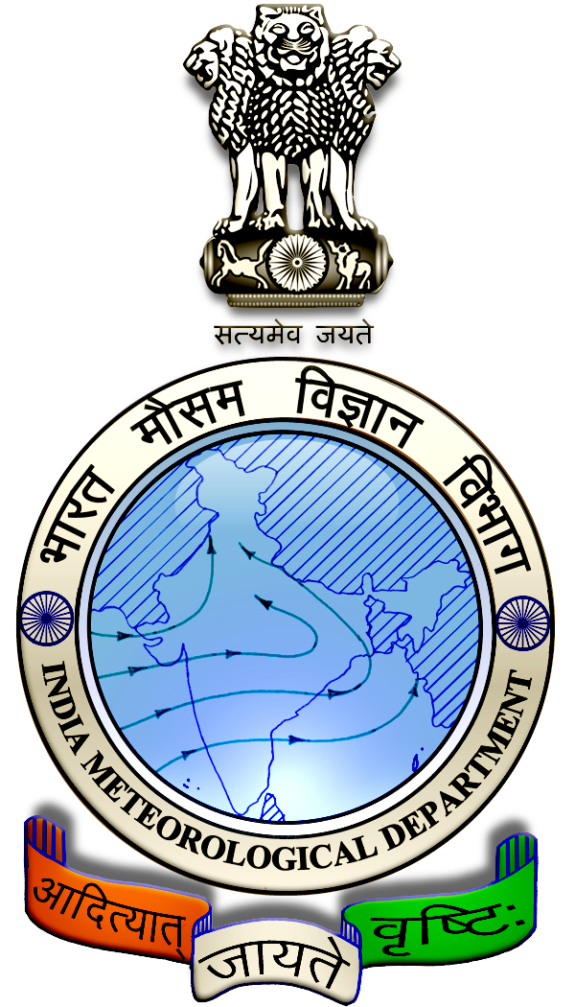
 | District : | Sivagangai | Forecast Period : | 09/11/2024 | to | 13/11/2024
 | Bulletine No : | MSSRF/SVG / 090/ 2024 | Release Date : | 08/11/2024

Significant past weather | From |  | 05/11/2024 | to | 07/11/2024
Parameters |  | Past Weather
Rainfall (mm) |  | 4.6
Maximum Temperature (ºC) |  | 33-35
Minimum Temperature (ºC) |  | 23-24
Sky Condition (Octas) |  | 2-5
Relative Humidity (%) |  | 55-89
Wind Speed (kmph) |  | 5-11

Ensemble Weather Forecast until | 08:30Hrs of | 13-11-2024
Parameters | 09-11-2024 | 10-11-2024 | 11-11-2024 | 12-11-2024 | 13-11-2024
Parameters | Saturday | Sunday | Monday | Tuesday | Wednesday
Rainfall (mm) | 24 | 0 | 0 | 0 | 2
Maximum Temperature (°C) | 34 | 33 | 33 | 34 | 34
Minimum Temperature (°C) | 25 | 24 | 24 | 24 | 24
Sky Condition (Octas) | 8 | 8 | 5 | 5 | 7
Max. Relative Humidity (%) | 90 | 90 | 90 | 90 | 80
Min. Relative Humidity (%) | 50 | 50 | 50 | 50 | 60
Wind Speed (Kmph) | 16 | 18 | 16 | 16 | 12
Wind Direction | NE | NE | NW | NW | NE

SMS Advisory | Chances of Moderate rain on 9 Nov. Maximum temperature would be in the range of 33℃ to 34℃ and the minimum temperature would be between 24℃ - 25℃. Generally cloudy sky will appear for the next five days. Wind is expected with the speed of 12-18 Kmph from, Northeast & Northwest directions.

General Advisory:
Extended range Forecast for next week (08th to 21st November 2024):
Rainfall:
As per extended range predictions, there is possibility of near normal to slightly above normal rainfall likely over the district during 08th to 14th November 2024.

As per extended range predictions, there is possibility of above normal rainfall likely over the district during 15th to 21st November 2024.

Maximum Temperature:
Maximum temperatures are likely to be generally near normal to slightly above normal and are likely to be in the range 28°C to 30°C over the plains of the district during next week. 08th to 14th November 2024.

Maximum temperatures are likely to be generally near normal and are likely to be in the range 26°C to 28°C over the plains of the district during next week. 15th to 21st November 2024.

Minimum Temperature:
Minimum temperatures are likely to be slightly above normal and are likely to be in the range 18°C to 22°C over the district during next week 08th to 21st November 2024.

Heavy Rainfall Warning:
Heavy rain is likely to occur at isolated places over the district on 9 November 2024. Farmers are advised to act swiftly to repair the water channels, farm ponds and other water bodies to harvest the rain water. During these days farmers are advised to avoid irrigation, intercultural operations and application of plant protection measures to the standing crops, provide adequate drainage facilities in the fields to avoid water stagnation due to heavy rainfall, do not allow the animals to grazing outside, standing near the trees or electric poles & provide safe shelter.

THUNDERSTORM WARNING:
Thunderstorm with lightning is likely to occur at one or two places over district during 9 to 13 November 2024. Keep your Livestock / Animals safely in the shelters. Don’t tie the animals to the electric poles and under trees.

To safeguard your animals from lightning and thunderstorm, remove the metal bells tied to the necks of animals.
Weather Based Agro-Advisories: (Cotton, Tomato & Animal Husbandry)
Cotton:
For the Cotton crop, if basal application was not given or cannot be done, fertilizer can be applied on the 25th day after sowing.

For varieties, apply 50% of N and K with a full dose of P as basal and the remaining 50% N and K at 40–45th DAS for varieties.

For hybrids, apply N in three splits viz., basal, 45, and 65 DAS.

Foliar applications of 2% DAP + 1% KCl or Polyfeed and Multi K can be sprayed to improve the yield.

Do not do crop protection activities like spraying, applying fertilizers on rainy days.

Tomato:
There are chances for rot disease in vegetable crops due to continuous rain. To avoid the spread of rot disease, spray or drench Copper Oxychloride @ 2gms per litre of water.

Spraying activities can be carried out on a non-rainy day.

Animal Husbandry:
Due to the prevailing weather conditions, the Enterotoxaemia disease may affect the Goats. The main symptom of the disease is sudden death in young growing kids. Mucous diarrhea may also be seen during death.

To prevent this disease, do not feed on young grass, allow the goat to graze one hour after the sunshine. Once in a year, contact the nearby veterinarian to vaccinate your animals.

