 | AgroMet Advisory Bulletin (AAB)  Jointly released by  Regional Meteorology Centre, Chennai – India Meteorology Department,  Reddiarchathram Seed Growers Association &  M. S. Swaminathan Research Foundation, Kannivadi  Phone no.: 044 - 22541229 E mail: amfu.kanniwadi@gmail.com Fax: 044 – 22541319 |  |  |  |  |  | 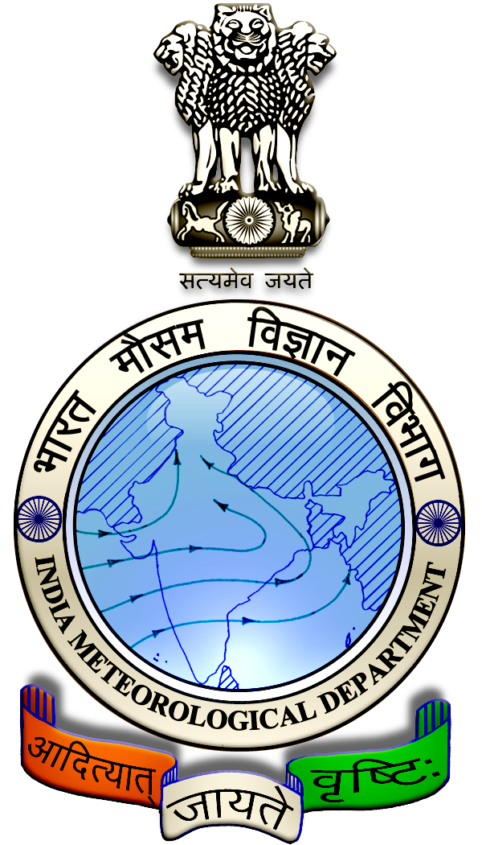
 | District : | Dindigul | Forecast Period : | 09/10/2024 | to | 13/10/2024
 | Bulletin No: | MSSRF/ DGL /081/ 2024 | Release Date : | 08/10/2024

Significant past weather | From |  | 04/10/2024 | to | 07/10/2024
Parameters |  | Past Weather
Rainfall (mm) |  | 21.3
Maximum Temperature (ºC) |  | 32-38
Minimum Temperature (ºC) |  | 25-26
Sky Condition (Octas) |  | 5-8
Relative Humidity (%) |  | 73-95
Wind Speed (kmph) |  | 6-8

Ensemble Weather Forecast until | 08:30Hrs of |  | 13-10-2024
Parameters | 09-10-2024 | 10-10-2024 |  | 11-10-2024 | 12-10-2024 | 13-10-2024
Parameters | Wednesday | Thursday |  | Friday | Saturday | Sunday
Rainfall (mm) | 22 | 24 |  | 25 | 23 | 21
Maximum Temperature (°C) | 34 | 33 |  | 32 | 31 | 30
Minimum Temperature (°C) | 25 | 24 |  | 23 | 21 | 21
Sky Condition (Octa) | 8 | 8 |  | 8 | 8 | 8
Max. Relative Humidity (%) | 80 | 80 |  | 90 | 90 | 90
Min. Relative Humidity (%) | 50 | 50 |  | 60 | 60 | 80
Wind Speed (Kmph) | 4 | 6 |  | 6 | 8 | 8
Wind Direction | S | NE |  | E | SE | NE

SMS Advisory | Chances of Moderate rain during 9, 10, 11, 12 & 13 Oct. Maximum temperature would be in the range of 30℃ to 34℃ and the minimum temperature would be between 21℃ - 25℃. Cloudy sky will appear for the next five days. Wind is expected with the speed of 4 – 8 Kmph from, South, Northeast, East & Southeast directions.

General Advisory:
Heavy rain is likely to occur at isolated places over the district during 9, 10, 11, 12 & 13 October 2024. Farmers are advised to act swiftly to repair the water channels, farm ponds and other water bodies to harvest the rain water. During these days farmers are advised to avoid irrigation, intercultural operations and application of plant protection measures to the standing crops, provide adequate drainage facilities in the fields to avoid water stagnation due to heavy rainfall, do not allow the animals to grazing outside, standing near the trees or electric poles & provide safe shelter.

Weather Based Agro-Advisories: (Maize, Paddy & Animal Husbandry)
Maize:
Farmers planning for maize cultivation are advised to treat the seeds before sowing. Select good quality seeds.

Adopt the seed rate @ 20kg/ha for hybrids and 25kg/ha. for varieties. Adopt a spacing of 45 cm between rows and 20 cm between plants in the row.
Seeds treated with fungicides may be treated with three packets (1600g/ha) of Azospirillum. Dibble the seeds at a depth of 4 cm.
Paddy:
This is the time for the application of Manures and Fertilizers in Paddy fields.

As a blanket recommendation, farmers should uniformly apply 50 kg of nitrogen (N), 28 kg of phosphorus (P), and 25 kg of potassium (K) per hectare.

Also apply 25 kg of N and 12 ½ kgs of K in two equal splits at 20 – 25 days and 40 - 45 days after germination.

Animal Husbandry:
Due to the prevailing weather condition, Enterotoxaemia disease may affect the Goats. The main symptom of the disease causes sudden death in young growing kids. Mucous diarrhoea may also be seen during death.

To prevent this disease, do not feed on young grass, allow the goat for grazing one hour after the sunshine. Immediately contact the nearest veterinary clinic and vaccinate your animals.

