 | AgroMet Advisory Bulletin (AAB)  Jointly released by  Regional Meteorology Centre, Chennai – India Meteorology Department,  Reddiarchathram Seed Growers Association &  M. S. Swaminathan Research Foundation, Kannivadi  Phone no.: 044 - 22541229 E mail: amfu.kanniwadi@gmail.com Fax: 044 – 22541319 |  |  |  |  |  | 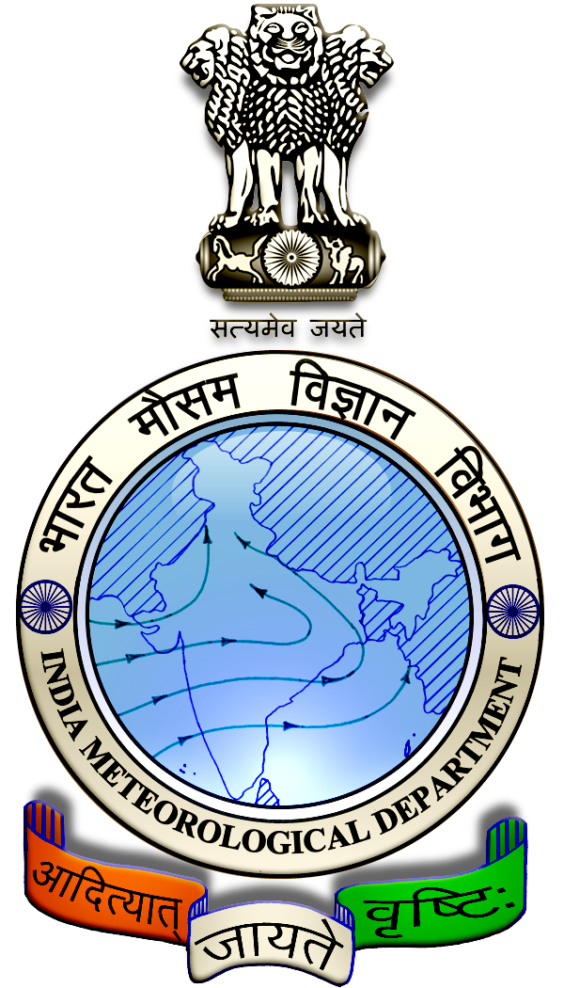
 | District : | Pudukkottai | Forecast Period : | 09/10/2024 | to | 13/10/2024
 | Bulletin No: | MSSRF/ PDK /081/ 2024 | Release Date : | 08/10/2024

Significant past weather | From |  | 04/10/2024 | to | 07/10/2024
Parameters |  | Past Weather
Rainfall (mm) |  | 76.6
Maximum Temperature (ºC) |  | 32-39
Minimum Temperature (ºC) |  | 23-27
Sky Condition (Octas) |  | 6-7
Relative Humidity (%) |  | 66-97
Wind Speed (kmph) |  | 7-17

Ensemble Weather Forecast until | 08:30Hrs of |  | 13-10-2024
Parameters | 09-10-2024 | 10-10-2024 |  | 11-10-2024 | 12-10-2024 | 13-10-2024
Parameters | Wednesday | Thursday |  | Friday | Saturday | Sunday
Rainfall (mm) | 2 | 7 |  | 7 | 15 | 22
Maximum Temperature (°C) | 34 | 33 |  | 32 | 32 | 31
Minimum Temperature (°C) | 25 | 24 |  | 23 | 23 | 22
Sky Condition (Octa) | 8 | 8 |  | 8 | 7 | 8
Max. Relative Humidity (%) | 80 | 80 |  | 90 | 90 | 90
Min. Relative Humidity (%) | 50 | 50 |  | 50 | 50 | 70
Wind Speed (Kmph) | 12 | 8 |  | 12 | 12 | 14
Wind Direction | S | SE |  | E | E | NE

SMS Advisory | Chances of light rain during 9, 10, 11 Oct & Moderate rain on 12, 13 Oct. Maximum temperature would be in the range of 31℃ to 34℃ and the minimum temperature would be between 22℃ - 25℃. Cloudy sky will appear for the next five days. Wind is expected with the speed of 8 – 14 Kmph from, South, Southeast, East & Northeast directions.

General Advisory:
Heavy rain is likely to occur at isolated places over the district on 13 October 2024. Farmers are advised to act swiftly to repair the water channels, farm ponds and other water bodies to harvest the rain water. During these days farmers are advised to avoid irrigation, intercultural operations and application of plant protection measures to the standing crops, provide adequate drainage facilities in the fields to avoid water stagnation due to heavy rainfall, do not allow the animals to grazing outside, standing near the trees or electric poles & provide safe shelter.

Weather Based Agro-Advisories: (Chilly, Paddy & Animal Husbandry)
Chilly:
The incense of Chilly Thrips is noticed in Chilly fields. The infected leaves develop crinkles and curl upwards. Elongated petiole, buds become brittle and drop down.
Early-stage, infestation leads to stunted growth and flower production, and fruit sets get arrested.
To avoid this, intercrop with Agathi crop (Sesbania grandiflora) to provide shade which regulates the Thrips population.
Sprinkle water over the seedlings to check the multiplication of Thrips.
Spray the insecticide Imidacloprid 17.8% SL @ 3ml/10 litres of water.

Paddy:
Before transplanting the paddy seedlings, the application of organic inputs in the field is essential for the Paddy crop.

Mix 2kg of Azospirillum per hectare and 2kg of Phosphobacteria per hectare or 4kg of Azophos inoculants with 25kg FYM and 25 kg of sand.

Broadcast the mixture uniformly in the main field before transplanting.

Spraying and fertilizer application activities should be carried out on non-rainy days.

Animal Husbandry:
Due to the prevailing weather condition, Enterotoxaemia disease may affect the Goats. The main symptom of the disease causes sudden death in young growing kids. Mucous diarrhoea may also be seen during death.

To prevent this disease, do not feed on young grass, allow the goat for grazing one hour after the sunshine. Immediately contact the nearest veterinary clinic and vaccinate your animals.

