 | AgroMet Advisory Bulletin (AAB)  Jointly released by  Regional Meteorology Centre, Chennai – India Meteorology Department,  Reddiarchathram Seed Growers Association &  M. S. Swaminathan Research Foundation, Kannivadi  Phone no.: 044 - 22541229 E mail: amfu.kanniwadi@gmail.com Fax: 044 – 22541319 |  |  |  |  |  | 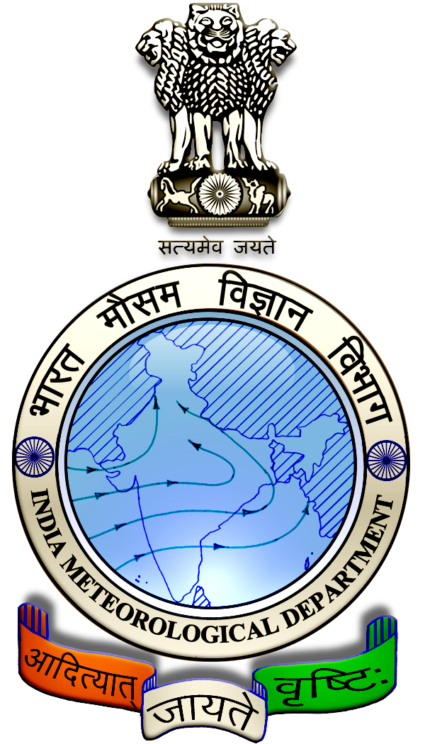
 | District : | Sivagangai | Forecast Period : | 16/10/2024 | to | 20/10/2024
 | Bulletine No : | MSSRF/SVG / 083/ 2024 | Release Date : | 15/10/2024

Significant past weather | From |  | 10/10/2024 | to | 14/10/2024
Parameters |  | Past Weather
Rainfall (mm) |  | 120.8
Maximum Temperature (ºC) |  | 31-35
Minimum Temperature (ºC) |  | 22-25
Sky Condition (Octas) |  | 6-8
Relative Humidity (%) |  | 65-91
Wind Speed (kmph) |  | 4-10

Ensemble Weather Forecast until | 08:30Hrs of | 20-10-2024
Parameters | 16-10-2024 | 17-10-2024 | 18-10-2024 | 19-10-2024 | 20-10-2024
Parameters | Wednesday | Thursday | Friday | Saturday | Sunday
Rainfall (mm) | 18 | 14 | 3 | 2 | 12
Maximum Temperature (°C) | 29 | 27 | 26 | 26 | 25
Minimum Temperature (°C) | 23 | 22 | 21 | 21 | 20
Sky Condition (Octas) | 8 | 8 | 8 | 8 | 8
Max. Relative Humidity (%) | 90 | 80 | 80 | 80 | 80
Min. Relative Humidity (%) | 70 | 50 | 50 | 60 | 60
Wind Speed (Kmph) | 6 | 8 | 12 | 10 | 10
Wind Direction | NW | SW | SW | S | S

SMS Advisory | Chances of Moderate rain during 16, 17, 20 Oct & light rain on 18, 19 Oct. Maximum temperature would be in the range of 25℃ to 29℃ and the minimum temperature would be between 20℃ - 23℃. Cloudy sky will appear for the next five days. Wind is expected with the speed of 6 – 12 Kmph from, Northwest, Southwest & South directions.

General Advisory:
Weather Warning:
Southwest monsoon has withdrawn from the entire country today, the 15th October 2024. Simultaneously, the Northeast monsoon rainfall activity has commenced over Tamil Nadu, Puducherry.

Yesterday’s low pressure area over southeast Bay of Bengal concentrated into a well marked low pressure area over the central part of south Bay of Bengal at 0530 IST of today, the 15th October, 2024 and persisted over the same region at 0830 IST of today.

It is likely to move west-northwestwards and intensify into a depression over southwest Bay of Bengal during next 24 hours.

It is likely to continue to move west-northwestwards towards north Tamil Nadu, Puducherry and adjoining south Andhra Pradesh coasts during subsequent 24 hours.

Yesterday’s cyclonic circulation over westcentral Bay of Bengal off south Andhra Pradesh coast extending upto 5.8 km above mean sea level tilting southwestwards with height persists.

Weather Based Agro-Advisories:
During these days farmers are advised to avoid Sowing, irrigation, intercultural operations and application of plant protection measures to the standing crops.

Provide adequate drainage facilities in the field and renovate the rain water harvesting structures to avoid water stagnation due to heavy rainfall. Try to harvest the rainwater in the farm ponds / water bodies.

Provide support to crops likes Banana, Papaya and sugarcane

Animal Husbandry:
Do not allow the animals to graze outside in open space, standing near the trees or electric poles; provide safe shelter to the animals.

