 | AgroMet Advisory Bulletin (AAB)  Jointly released by  Regional Meteorology Centre, Chennai – India Meteorology Department,  Reddiarchathram Seed Growers Association &  M. S. Swaminathan Research Foundation, Kannivadi  Phone no.: 044 - 22541229 E mail: amfu.kanniwadi@gmail.com Fax: 044 – 22541319 |  |  |  |  |  | 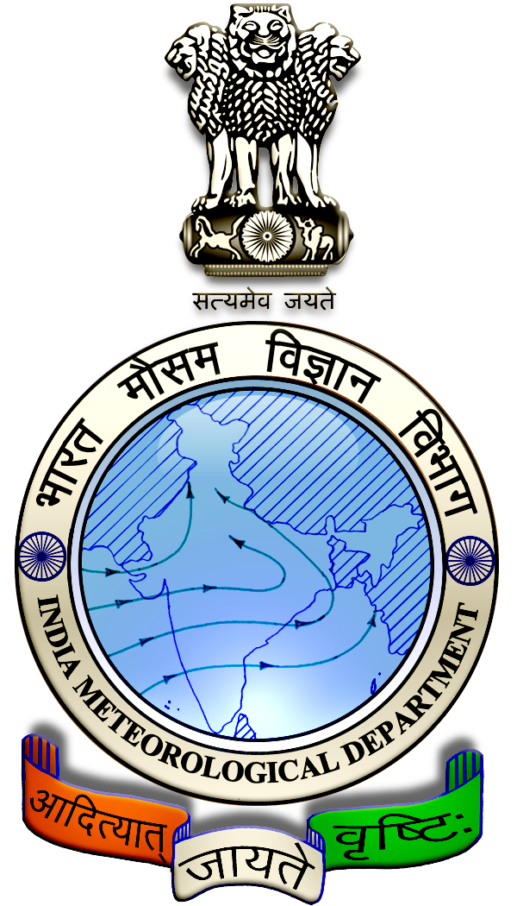
 | District : | Theni | Forecast Period : | 09/10/2024 | to | 13/10/2024
 | Bulletine No : | MSSRF/ THN/ 081/ 2024 | Release Date : | 08/10/2024

Significant past weather | From |  | 04/10/2024 | to | 07/10/2024
Parameters |  | Past Weather
Rainfall (mm) |  | 4.0
Maximum Temperature (ºC) |  | 32-38
Minimum Temperature (ºC) |  | 25-26
Sky Condition (Octas) |  | 5-8
Relative Humidity (%) |  | 73-95
Wind Speed (kmph) |  | 6-8

Ensemble Weather Forecast until | 08:30Hrs of | 13-10-2024
Parameters | 09-10-2024 | 10-10-2024 | 11-10-2024 | 12-10-2024 | 13-10-2024
Parameters | Wednesday | Thursday | Friday | Saturday | Sunday
Rainfall (mm) | 22 | 22 | 24 | 26 | 25
Maximum Temperature (°C) | 32 | 31 | 30 | 29 | 29
Minimum Temperature (°C) | 22 | 21 | 20 | 20 | 19
Sky Condition (Octas) | 8 | 8 | 8 | 8 | 8
Max. Relative Humidity (%) | 80 | 80 | 90 | 90 | 90
Min. Relative Humidity (%) | 50 | 50 | 60 | 60 | 80
Wind Speed (Kmph) | 6 | 4 | 4 | 6 | 6
Wind Direction | SW | NW | NW | NE | NE

SMS Advisory | Chances of Moderate rain during 9, 10, 11, 12 & 13 Oct. Maximum temperature would be in the range of 29℃ to 32℃ and the minimum temperature would be between 19℃ - 22℃. Cloudy sky will appear for the next five days. Wind is expected with the speed of 4 – 6 Kmph from, Southwest, Northwest & Northeast directions.

General Advisory:
Heavy rain is likely to occur at isolated places over the district during 9, 10, 11, 12 & 13 October 2024. Farmers are advised to act swiftly to repair the water channels, farm ponds and other water bodies to harvest the rain water. During these days farmers are advised to avoid irrigation, intercultural operations and application of plant protection measures to the standing crops, provide adequate drainage facilities in the fields to avoid water stagnation due to heavy rainfall, do not allow the animals to grazing outside, standing near the trees or electric poles & provide safe shelter.

Weather Based Agro-Advisories: (Banana, Brinjal & Animal Husbandry)
Banana:
Moderate rainfall is expected for the coming days, using these weather conditions, Banana cultivators are advised to apply the biological inputs Azospirillum and Phosphobacteria, @ 20 grams of each per plant, which are in the growing stage, 5 months after planting.

Brinjal:
The occurrence of sucking pests like Aphids & whiteflies may be noticed in the Brinjal crop.

To control, mix Neem Oil @ 50ml + Pseudomonas @ 50gm + Sticky agent @ 10ml with 10 litres of water. Spray 2 times at 10 days intervals.

Tie Yellow sticky traps @ 10 per acre and Blue sticky traps @ 5 per acre.

Animal Husbandry:
Due to the prevailing weather condition, Enterotoxaemia disease may affect the Goats. The main symptom of the disease causes sudden death in young growing kids. Mucous diarrhoea may also be seen during death.

To prevent this disease, do not feed on young grass, allow the goat for grazing one hour after the sunshine. Immediately contact the nearest veterinary clinic and vaccinate your animals.

