 | AgroMet Advisory Bulletin (AAB)  Jointly released by  Regional Meteorology Centre, Chennai – India Meteorology Department,  Reddiarchathram Seed Growers Association &  M. S. Swaminathan Research Foundation, Kannivadi  Phone no.: 044 - 22541229 E mail: amfu.kanniwadi@gmail.com Fax: 044 – 22541319 |  |  |  |  |  | 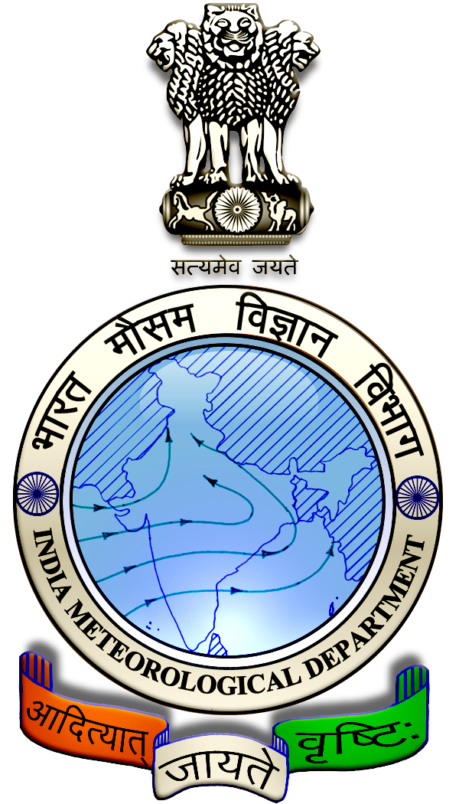
 | District : | Dindigul | Forecast Period : | 04/09/2024 | to | 08/09/2024
 | Bulletin No: | MSSRF/ DGL /071/ 2024 | Release Date : | 03/09/2024

Significant past weather | From |  | 30/08/2024 | to | 02/09/2024
Parameters |  | Past Weather
Rainfall (mm) |  | 3.2
Maximum Temperature (ºC) |  | 35-39
Minimum Temperature (ºC) |  | 25-26
Sky Condition (Octas) |  | 4-7
Relative Humidity (%) |  | 48-73
Wind Speed (kmph) |  | 2-12

Ensemble Weather Forecast until | 08:30Hrs of |  | 08-09-2024
Parameters | 04-09-2024 | 05-09-2024 |  | 06-09-2024 | 07-09-2024 | 08-09-2024
Parameters | Wednesday | Thursday |  | Friday | Saturday | Sunday
Rainfall (mm) | 3 | 4 |  | 1 | 1 | 2
Maximum Temperature (°C) | 38 | 37 |  | 37 | 37 | 37
Minimum Temperature (°C) | 26 | 25 |  | 25 | 25 | 24
Sky Condition (Octa) | 6 | 8 |  | 7 | 6 | 8
Max. Relative Humidity (%) | 70 | 70 |  | 70 | 70 | 70
Min. Relative Humidity (%) | 40 | 40 |  | 30 | 40 | 40
Wind Speed (Kmph) | 12 | 12 |  | 14 | 14 | 12
Wind Direction | NW | NW |  | NW | NW | NW

SMS Advisory | Chances of light rain during 4, 5 & 8 Sep. Maximum temperature would be in the range of 37℃ to 38℃ and the minimum temperature would be between 24℃ - 26℃. Generally cloudy sky will appear for the next five days. Wind is expected with the speed of 12 – 14 Kmph from, Northwest direction.

General Advisory:
Extended range Forecast for next week (06th to 12th September 2024):
Rainfall:
As per extended range predictions, there is possibility of below normal rainfall likely over the district during 06th to 12th September 2024.

Maximum Temperature:
Maximum temperatures are likely to be near normal to slightly above normal and are likely to be in the range 26°C to 32°C over the plains of the district during next week. 06th to 12th September 2024.

Minimum Temperature:
Minimum temperatures are likely to be near normal to slightly above normal and are likely to be in the range 20°C to 24°C over the district during next week 06th to 12th September 2024.

Animal Husbandry:
Light to Moderate rain with thunderstorm and lightning is likely to occur at isolated places over district during 4 & 5 September 2024. Keep your Livestock / Animals safely in the shelters. Don’t tie the animals to the electric poles and under trees.

To safeguard your animals from lightning and thunderstorm, remove the metal bells tied to the necks of animals.

Weather Based Agro-Advisories: (Chilly, Maize & Animal Husbandry)
Chilly:
Farmers planning to cultivate chillies are advised to undergo the seed treatment process.

To control seed-borne apical blight and fruit rot disease, treat the seeds with Trichoderma viride @ 10gm per kg of seed and Pseudomonas fluorescence @ 10 gm mix and keep it for 24 hours and sow in lines spaced at 10cm in raised nursery beds and cover with sand.

Maize:
The application of micronutrients will rectify the nutrient deficiency in Maize Cultivation.

Farmers who have planted maize recently can apply 5kg of Millet nutrient mixture or 10Kg of ZnSo4 /acre.

Also, apply Farm Yard Manure along with 2kgs of Azosphirillum and 2kgs of Phosphobacteria per acre.

Animal Husbandry:
Despite the fact that green fodder is abundantly available during the rainy season there are more chances for consumption of green fodder by cattle.

Due to that an increase in consumption of green fodder can lead to the occurrence of green diarrhoea and a problem of Acidosis.

Ensure that the fodder given to animals is mixed with larger quantities of dry fodder at this time.

