 | AgroMet Advisory Bulletin (AAB)  Jointly released by  Regional Meteorology Centre, Chennai – India Meteorology Department,  Reddiarchathram Seed Growers Association &  M. S. Swaminathan Research Foundation, Kannivadi  Phone no.: 044 - 22541229 E mail: amfu.kanniwadi@gmail.com Fax: 044 – 22541319 |  |  |  |  |  | 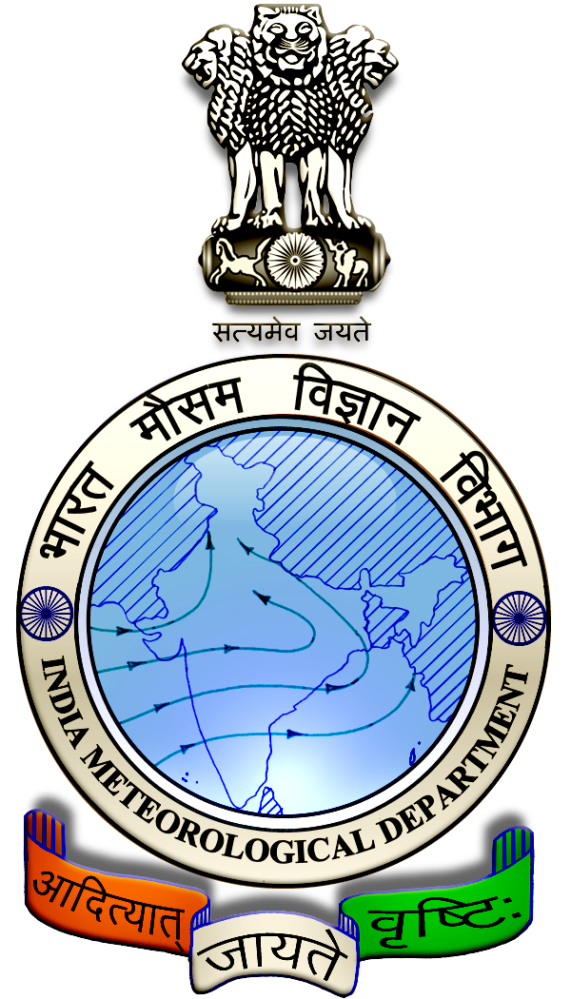
 | District : | Madurai | Forecast Period : | 04/09/2024 | to | 08/09/2024
 | Bulletine No : | MSSRF/ MDU / 071/ 2024 | Release Date : | 03/09/2024

Significant past weather | From |  | 30/08/2024 | to | 02/09/2024
Parameters |  | Past Weather
Rainfall (mm) |  | 0.3
Maximum Temperature (ºC) |  | 35-39
Minimum Temperature (ºC) |  | 25-26
Sky Condition (Octas) |  | 4-7
Relative Humidity (%) |  | 48-73
Wind Speed (kmph) |  | 2-12

Ensemble Weather Forecast until | 08:30Hrs of | 08-09-2024
Parameters | 04-09-2024 | 05-09-2024 | 06-09-2024 | 07-09-2024 | 08-09-2024
Parameters | Wednesday | Thursday | Friday | Saturday | Sunday
Rainfall (mm) | 2 | 3 | 1 | 2 | 2
Maximum Temperature (°C) | 38 | 37 | 37 | 37 | 37
Minimum Temperature (°C) | 26 | 25 | 25 | 25 | 24
Sky Condition (Octas) | 6 | 8 | 7 | 6 | 8
Max. Relative Humidity (%) | 70 | 70 | 70 | 70 | 70
Min. Relative Humidity (%) | 40 | 40 | 30 | 40 | 40
Wind Speed (Kmph) | 8 | 8 | 10 | 8 | 10
Wind Direction | NW | NW | NW | NW | NW

SMS Advisory | Chances of light rain during 4, 5, 7 & 8 Sep. Maximum temperature would be in the range of 37℃ to 38℃ and the minimum temperature would be between 24℃ - 26℃. Generally cloudy sky will appear for the next five days. Wind is expected with the speed of 8 – 10 Kmph from, Northwest direction.

General Advisory:
Extended range Forecast for next week (06th to 12th September 2024):
Rainfall:
As per extended range predictions, there is possibility of below normal rainfall likely over the district during 06th to 12th September 2024.

Maximum Temperature:
Maximum temperatures are likely to be near normal to slightly above normal and are likely to be in the range 26°C to 32°C over the plains of the district during next week. 06th to 12th September 2024.

Minimum Temperature:
Minimum temperatures are likely to be near normal to slightly above normal and are likely to be in the range 20°C to 24°C over the district during next week 06th to 12th September 2024.

Animal Husbandry:
Light to Moderate rain with thunderstorm and lightning is likely to occur at isolated places over district during 4 & 5 September 2024. Keep your Livestock / Animals safely in the shelters. Don’t tie the animals to the electric poles and under trees.

To safeguard your animals from lightning and thunderstorm, remove the metal bells tied to the necks of animals.

Weather Based Agro-Advisories: (Sugarcane, Paddy & Animal Husbandry)
Sugarcane:
Symptoms of Phosphorus deficiency is observed in the Sugarcane fields. The Colour of the leaves will be greenish-blue, reduction in the length of sugarcane stalks, diameters of which taper rapidly at growing points.

Poor or no-tillers, decreased shoot/root ratio with restricted root development are the symptoms of damage.

To rectify this, apply a large amount of rock phosphate up to 1 Tonne/ha. Foliar spray of DAP @ 20gm/litre, twice in fortnight intervals.

Paddy:
Due to the prevailing weather conditions the incense of Blast is seen in paddy. The disease can infect paddy crop at all growth stages and all aerial parts of the plant (Leaf, neck and node). Among the three, leaves and neck infections are more severe.

Small specks originate on leaves and, subsequently enlarge into spindle-shaped spots with ashy centres. Several spots coalesce, big irregular patches.

Remove collateral weed hosts from bunds and channels, avoid excess nitrogen,

Apply N in three split doses (50% basal, 25% in the Tillering phase and 25% N in the panicle initiation stage).

After observing the initial infection of the disease, spray Tricyclozole 75 WP @ 100g/acre.

Animal Husbandry:
Despite the fact that green fodder is abundantly available during the rainy season there are more chances for consumption of green fodder by cattle.

Due to that an increase in consumption of green fodder can lead to the occurrence of green diarrhoea and a problem of Acidosis.

Ensure that the fodder given to animals is mixed with larger quantities of dry fodder at this time.

