 | AgroMet Advisory Bulletin (AAB)  Jointly released by  Regional Meteorology Centre, Chennai – India Meteorology Department,  Reddiarchathram Seed Growers Association &  M. S. Swaminathan Research Foundation, Kannivadi  Phone no.: 044 - 22541229 E mail: amfu.kanniwadi@gmail.com Fax: 044 – 22541319 |  |  |  |  |  | 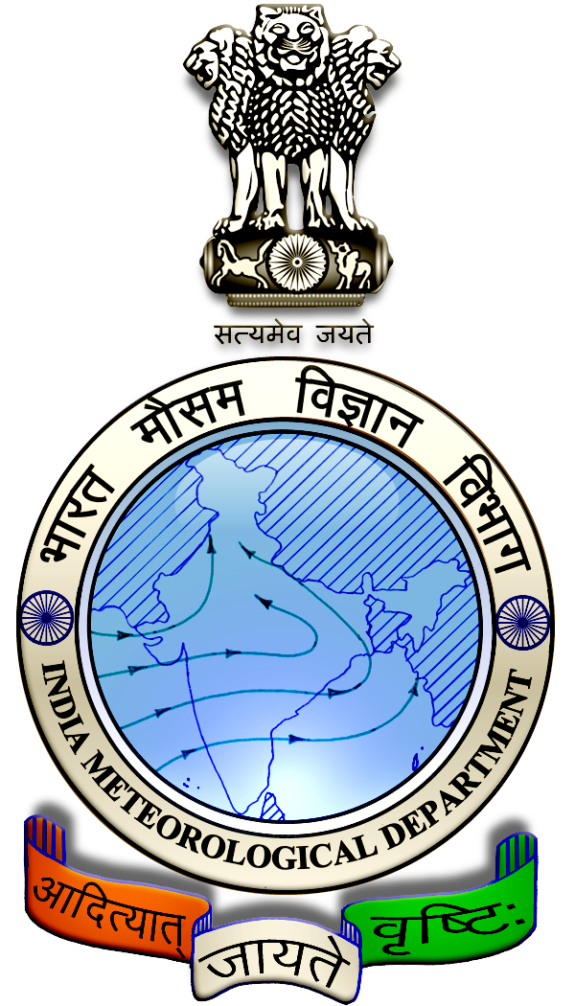
 | District : | Madurai | Forecast Period : | 11/09/2024 | to | 15/09/2024
 | Bulletine No : | MSSRF/ MDU / 073/ 2024 | Release Date : | 10/09/2024

Significant past weather | From |  | 06/09/2024 | to | 09/09/2024
Parameters |  | Past Weather
Rainfall (mm) |  | 0.0
Maximum Temperature (ºC) |  | 39-41
Minimum Temperature (ºC) |  | 26-27
Sky Condition (Octas) |  | 5-6
Relative Humidity (%) |  | 42-65
Wind Speed (kmph) |  | 9-15

Ensemble Weather Forecast until | 08:30Hrs of | 15-09-2024
Parameters | 11-09-2024 | 12-09-2024 | 13-09-2024 | 14-09-2024 | 15-09-2024
Parameters | Wednesday | Thursday | Friday | Saturday | Sunday
Rainfall (mm) | 0 | 0 | 0 | 1 | 1
Maximum Temperature (°C) | 38 | 38 | 37 | 36 | 36
Minimum Temperature (°C) | 26 | 25 | 24 | 24 | 23
Sky Condition (Octas) | 4 | 6 | 7 | 8 | 8
Max. Relative Humidity (%) | 70 | 70 | 70 | 70 | 70
Min. Relative Humidity (%) | 40 | 40 | 40 | 40 | 40
Wind Speed (Kmph) | 14 | 10 | 10 | 12 | 8
Wind Direction | W | NW | NW | W | NW

SMS Advisory | Chances of very light rain on 14 & 15 Sep. Maximum temperature would be in the range of 36℃ to 38℃ and the minimum temperature would be between 23℃ - 26℃. Generally cloudy sky will appear for the next five days. Wind is expected with the speed of 8 – 14 Kmph from, West & Northwest directions.

General Advisory:
Agriculture:
Farmers cultivating sugarcane and vegetables crops in rain-fed lands should provide rows and furrows at regular intervals and irrigate through furrows.

Irrigation water is economical as it is moistened only in the furrow area. Rain water drains easily if it gets stagnant in furrows.

In times of water scarcity, water can be saved by irrigating it with furrows. Intercropping is easy as the crops are arranged in rows.

Livestock:
Light to Moderate rain with thunderstorm and lightning is likely to occur at isolated places over district on 11 & 12 September 2024. Farmers are advised to take precautionary measures while grazing/herding the sheep, goat, cow on agriculture land for manuring purpose.

Do not allow the animals to graze outside, standing near the trees or electric poles. Provide safe shelter for your livestock.

Weather Based Agro-Advisories: (Paddy, Jasmine & Animal Husbandry)
Paddy:
The incense of Rice horned caterpillar noticed in Paddy. The Larva feeds on leaf blades of rice. Leaves are defoliated from the margin or tip irregularly. To control this, drain the excess water from the field. To manage this pest, foliar spray of Emamectin Benzoate @ 6gms per tank or Flubendiamide @ 20ml per acre is recommended.

Jasmine:
The incense of Collar and Root Rot disease is expected in Jasmine. Plants at all stages are infected by this disease.

The symptoms are, initially, the older leaves become yellow followed by younger leaves and finally, the plant will die. Black discolouration can be seen on the root part.

To control this, remove and destroy the affected plant from the field.

Soil drenching of Copper Oxychloride @ 2 ½ gm per litre of water per plant is recommended.

Animal Husbandry:
Due to the prevailing weather, external parasites may attack your goats and sheep.

If symptoms are found, to protect your livestock from these external parasites, mix 2ml of Butox with one litre of water and apply the solution to the outer body of the sheep.

This medicine should not be used internally.

