 | AgroMet Advisory Bulletin (AAB)  Jointly released by  Regional Meteorology Centre, Chennai – India Meteorology Department,  Reddiarchathram Seed Growers Association &  M. S. Swaminathan Research Foundation, Kannivadi  Phone no.: 044 - 22541229 E mail: amfu.kanniwadi@gmail.com Fax: 044 – 22541319 |  |  |  |  |  | 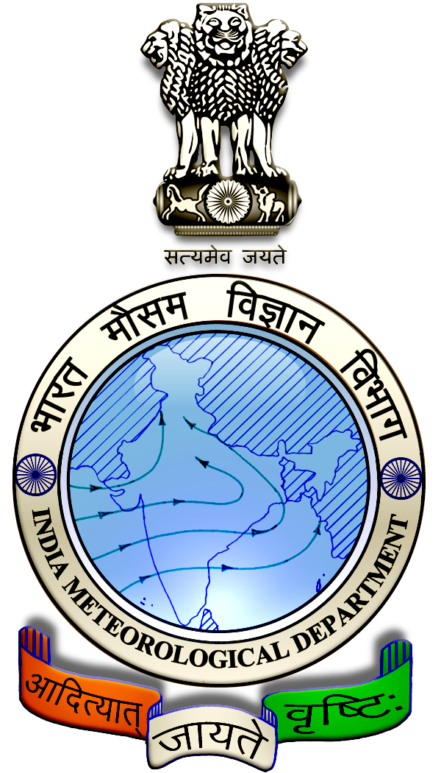
 | District : | Madurai | Forecast Period : | 17/09/2024 | to | 21/09/2024
 | Bulletine No : | MSSRF/ MDU / 075/ 2024 | Release Date : | 16/09/2024

Significant past weather | From |  | 13/09/2024 | to | 15/09/2024
Parameters |  | Past Weather
Rainfall (mm) |  | 0.0
Maximum Temperature (ºC) |  | 40-41
Minimum Temperature (ºC) |  | 26-27
Sky Condition (Octas) |  | 4-6
Relative Humidity (%) |  | 39-58
Wind Speed (kmph) |  | 7-13

Ensemble Weather Forecast until | 08:30Hrs of | 21-09-2024
Parameters | 17-09-2024 | 18-09-2024 | 19-09-2024 | 20-09-2024 | 21-09-2024
Parameters | Tuesday | Wednesday | Thursday | Friday | Saturday
Rainfall (mm) | 1 | 0 | 0 | 0 | 0
Maximum Temperature (°C) | 41 | 41 | 40 | 41 | 41
Minimum Temperature (°C) | 28 | 28 | 27 | 27 | 28
Sky Condition (Octas) | 7 | 4 | 4 | 0 | 0
Max. Relative Humidity (%) | 60 | 70 | 70 | 70 | 70
Min. Relative Humidity (%) | 30 | 30 | 30 | 30 | 30
Wind Speed (Kmph) | 10 | 8 | 8 | 10 | 10
Wind Direction | W | W | W | NW | W

SMS Advisory | Chances of very light rain on 17 Sep. Maximum temperature would be in the range of 40℃ to 41℃ and the minimum temperature would be between 27℃ - 28℃. Partly cloudy sky will appear for the next five days. Wind is expected with the speed of 8 – 10 Kmph from, West & Northwest directions.

General Advisory:
Extended range Forecast for next week (20th to 26th September 2024):

Rainfall:
As per extended range predictions, there is possibility of near normal rainfall likely over the district during 20th to 26th September 2024.

Maximum Temperature:
Maximum temperatures are likely to be near normal to generally above normal and are likely to be in the range 28°C to 32°C over the plains of the district during next week. 20th to 26th September 2024.

Minimum Temperature:
Minimum temperatures are likely to be near normal to slightly above normal and are likely to be in the range 20°C to 24°C over the district during next week 20th to 26th September 2024.

Agriculture:
There is a rise in maximum temperature for the forthcoming days, and due to this the soil moisture content may be reduced.

Hence, the horticultural farmers are advised to take up mulching around the root basin of the crop with dried leaves, grass and other farm wastes to retain the soil moisture content.

Due to hot and humid conditions, discomfort weather is likely at isolated pockets over the district on next two days (17.09.2024 & 18.09.2024). Hence farmers are advised to plan their field activities during morning and evening hours and avoid working in the field during 12 noon to 4 Pm. Stay safe and take care. Drink adequate water.

Weather Based Agro-Advisories: (Paddy, Sugarcane & Animal Husbandry)
Paddy:
Kind attention to Paddy cultivators, paddy crops are prone to the attack of sap sucking insects due to high humidity in the air. Spray Azadirachtin @ 2ml/litre of water with sticking paste, to control thrips and sap sucking insects.

Sugarcane:
Top dressing with fertilizers will give good results in Sugarcane cultivation.

In the case of the lift irrigation belt, apply 225 kg of nitrogen and 112 ½ kg of K2O per hectare in three equal splits during 30, 60 and 90 days.

Animal Husbandry:
The utensils used for milking can become grossly contaminated by bacteria on ancillary equipment which must also be cleaned and disinfected effectively.

Refrigerated bulk milk tanks can be cleaned either manually using cold or warm detergent/disinfectant solutions, or for the larger tanks, by automatic, programmed equipment.

In either case, cold water chlorinated (50 ppm) rinse proceeds and follows the washing solution. They should then be stored in the dairy to drain.

