 | AgroMet Advisory Bulletin (AAB)  Jointly released by  Regional Meteorology Centre, Chennai – India Meteorology Department,  Reddiarchathram Seed Growers Association &  M. S. Swaminathan Research Foundation, Kannivadi  Phone no.: 044 - 22541229 E mail: amfu.kanniwadi@gmail.com Fax: 044 – 22541319 |  |  |  |  |  | 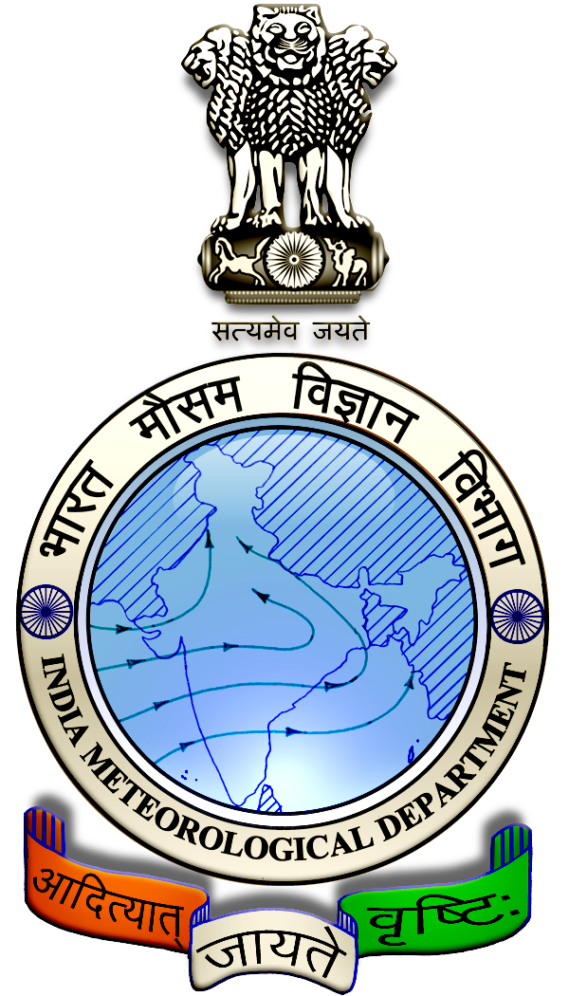
 | District : | Pudukkottai | Forecast Period : | 17/09/2024 | to | 21/09/2024
 | Bulletin No: | MSSRF/ PDK /075/ 2024 | Release Date : | 16/09/2024

Significant past weather | From |  | 13/09/2024 | to | 15/09/2024
Parameters |  | Past Weather
Rainfall (mm) |  | 0.2
Maximum Temperature (ºC) |  | 37-39
Minimum Temperature (ºC) |  | 27
Sky Condition (Octas) |  | 5-7
Relative Humidity (%) |  | 34-64
Wind Speed (kmph) |  | 21-24

Ensemble Weather Forecast until | 08:30Hrs of |  | 21-09-2024
Parameters | 17-09-2024 | 18-09-2024 |  | 19-09-2024 | 20-09-2024 | 21-09-2024
Parameters | Tuesday | Wednesday |  | Thursday | Friday | Saturday
Rainfall (mm) | 0 | 0 |  | 0 | 0 | 0
Maximum Temperature (°C) | 38 | 38 |  | 37 | 38 | 38
Minimum Temperature (°C) | 27 | 27 |  | 27 | 27 | 26
Sky Condition (Octa) | 8 | 2 |  | 7 | 4 | 1
Max. Relative Humidity (%) | 70 | 70 |  | 60 | 60 | 60
Min. Relative Humidity (%) | 30 | 20 |  | 30 | 30 | 20
Wind Speed (Kmph) | 14 | 12 |  | 12 | 12 | 12
Wind Direction | NW | W |  | SW | SW | SW

SMS Advisory | For the next five days, Maximum temperature would be in the range of 37℃ to 38℃and the minimum temperature would be between 26℃ - 27℃. Partly cloudy sky will appear for the next five days. Wind is expected with the speed of 12 – 14 Kmph from, Northwest, West & Southwest directions.

General Advisory:
Extended range Forecast for next week (20th to 26th September 2024):

Rainfall:
As per extended range predictions, there is possibility of generally above normal rainfall likely over the district during 20th to 26th September 2024.

Maximum Temperature:
Maximum temperatures are likely to be near normal to generally above normal and are likely to be in the range 34°C to 38°C over the plains of the district during next week. 20th to 26th September 2024.

Minimum Temperature:
Minimum temperatures are likely to be near normal to slightly above normal and are likely to be in the range 24°C to 26°C over the district during next week 20th to 26th September 2024.

Agriculture:
There is a rise in maximum temperature for the forthcoming days, and due to this the soil moisture content may be reduced.

Hence, the horticultural farmers are advised to take up mulching around the root basin of the crop with dried leaves, grass and other farm wastes to retain the soil moisture content.

Due to hot and humid conditions, discomfort weather is likely at isolated pockets over the district on next two days (17.09.2024 & 18.09.2024). Hence farmers are advised to plan their field activities during morning and evening hours and avoid working in the field during 12 noon to 4 Pm. Stay safe and take care. Drink adequate water.

Weather Based Agro-Advisories: (Guava, Paddy & Animal Husbandry)
Guava:
Micronutrient deficiency is noticed in Guava fruit crops, due to this, the leaves become smaller, the spacing between the nodes decreases, the plants look like shrubs, the leaves turn pale and the edges look wilted.

The spraying of micronutrients controls the bronzing of leaves. A combined spray should be given containing ZnSo4, MgSo4, MnSo4 @ 25gms, Borax @ 50gms and CuSO4 and FeSO4 @ 25grams with sticky agent @ 10ml per 10 litres of water.

Spray four times, once when new shoots appear and second, a month later, third and fourth times during the flowering and fruiting stages.

Paddy:
The incidence of Whorl maggot is expected in paddy. The symptoms show yellowish-white longitudinal marginal blotching with a hole.

Leaves shriveled plant, stunted and drooping of young leaves near the tip.
Remove the alternate hosts from the field, and apply the optimum recommendation of potash fertilizer.

To control spray Buprofezin @ 350 ml/acre.

Animal Husbandry:
The utensils used for milking can become grossly contaminated by bacteria on ancillary equipment which must also be cleaned and disinfected effectively.

Refrigerated bulk milk tanks can be cleaned either manually using cold or warm detergent/disinfectant solutions, or for the larger tanks, by automatic, programmed equipment.

In either case, cold water chlorinated (50 ppm) rinse proceeds and follows the washing solution. They should then be stored in the dairy to drain.

