 | AgroMet Advisory Bulletin (AAB)  Jointly released by  Regional Meteorology Centre, Chennai – India Meteorology Department,  Reddiarchathram Seed Growers Association &  M. S. Swaminathan Research Foundation, Kannivadi  Phone no.: 044 - 22541229 E mail: amfu.kanniwadi@gmail.com Fax: 044 – 22541319 |  |  |  |  |  | 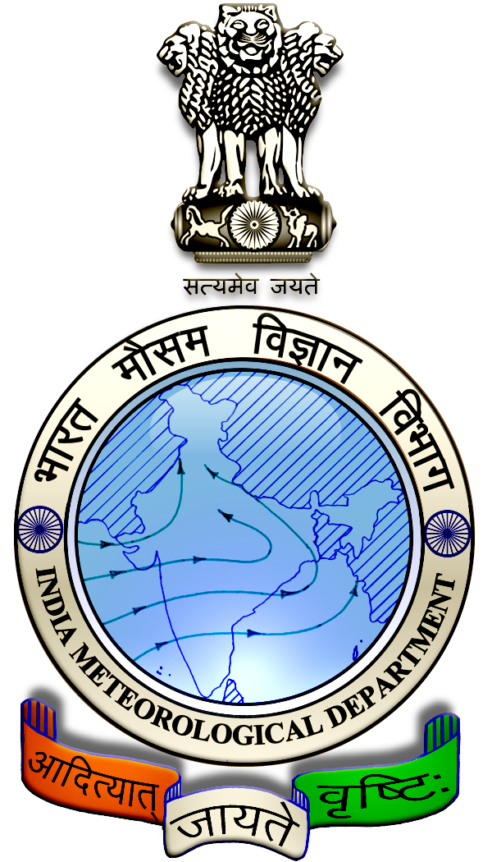
 | District : | Sivagangai | Forecast Period : | 04/09/2024 | to | 08/09/2024
 | Bulletine No : | MSSRF/SVG / 071/ 2024 | Release Date : | 03/09/2024

Significant past weather | From |  | 30/08/2024 | to | 02/09/2024
Parameters |  | Past Weather
Rainfall (mm) |  | 7.1
Maximum Temperature (ºC) |  | 35-39
Minimum Temperature (ºC) |  | 25-26
Sky Condition (Octas) |  | 4-7
Relative Humidity (%) |  | 48-73
Wind Speed (kmph) |  | 2-12

Ensemble Weather Forecast until | 08:30Hrs of | 08-09-2024
Parameters | 04-09-2024 | 05-09-2024 | 06-09-2024 | 07-09-2024 | 08-09-2024
Parameters | Wednesday | Thursday | Friday | Saturday | Sunday
Rainfall (mm) | 1 | 1 | 0 | 0 | 2
Maximum Temperature (°C) | 38 | 37 | 37 | 37 | 37
Minimum Temperature (°C) | 26 | 25 | 25 | 25 | 24
Sky Condition (Octas) | 6 | 8 | 7 | 6 | 8
Max. Relative Humidity (%) | 70 | 70 | 70 | 70 | 70
Min. Relative Humidity (%) | 40 | 40 | 30 | 40 | 40
Wind Speed (Kmph) | 8 | 10 | 12 | 10 | 10
Wind Direction | SW | SW | SW | SW | SW

SMS Advisory | Chances of very light rain during 4, 5 & 8 Sep. Maximum temperature would be in the range of 37℃ to 38℃ and the minimum temperature would be between 24℃ - 26℃. Generally cloudy sky will appear for the next five days. Wind is expected with the speed of 8 – 12 Kmph from, Southwest direction.

General Advisory:
Extended range Forecast for next week (06th to 12th September 2024):
Rainfall:
As per extended range predictions, there is possibility of below normal rainfall likely over the district during 06 to 12th September 2024.

Maximum Temperature:
Maximum temperatures are likely to be near normal to slightly above normal and are likely to be in the range 26°C to 32°C over the plains of the district during next week. 06 to 12th September 2024.

Minimum Temperature:
Minimum temperatures are likely to be near normal to slightly above normal and are likely to be in the range 20°C to 24°C over the district during next week 06 to 12th September 2024.

Animal Husbandry:
Light to Moderate rain with thunderstorm and lightning is likely to occur at isolated places over district during 4 & 5 September 2024. Keep your Livestock / Animals safely in the shelters. Don’t tie the animals to the electric poles and under trees.

To safeguard your animals from lightning and thunderstorm, remove the metal bells tied to the necks of animals.

Weather Based Agro-Advisories: (Pearl millet, Tomato & Animal Husbandry)
Pearl millet:
It is important to manage weeds in direct sowing of Bajra seed. Mix 0.25 kg of atrazine 0.25 kg per ha in 500 litres of water and spray on the soil surface with the help of a sprayer fitted with a flat-type nozzle, before germination after 3 days of sowing.

If there is sufficient moisture in the soil, use herbicides before weed germination. If weedicide is not sprayed before weed germination, manual weeding twice at 15 and 30 days after sowing is recommended.

Tomato:
The incense of Mosaic virus disease is noticed in Tomato crops. The disease is characterized by light and day green mottling on the leaves often accompanied by wilting of young leaves on sunny days when plants first become infected. The affected plant appears stunted, pale green and spindly.

Soak the seeds in a solution of Tri-sodium Phosphate (90gm/litre of water) a day before sowing helps to reduce the disease incidence. The seeds should be thoroughly rinsed and dried in the shade.

Seedlings infected with the viral disease should not be used for transplanting. Crop rotation with crops other than tobacco, potato, chilli, capsicum, Brinjal, etc. should be undertaken.

Animal Husbandry:
Despite the fact that green fodder is abundantly available during the rainy season there are more chances for consumption of green fodder by cattle.

Due to that an increase in consumption of green fodder can lead to the occurrence of green diarrhoea and a problem of Acidosis.

Ensure that the fodder given to animals is mixed with larger quantities of dry fodder at this time.

