 | AgroMet Advisory Bulletin (AAB)  Jointly released by  Regional Meteorology Centre, Chennai – India Meteorology Department,  Reddiarchathram Seed Growers Association &  M. S. Swaminathan Research Foundation, Kannivadi  Phone no.: 044 - 22541229 E mail: amfu.kanniwadi@gmail.com Fax: 044 – 22541319 |  |  |  |  |  | 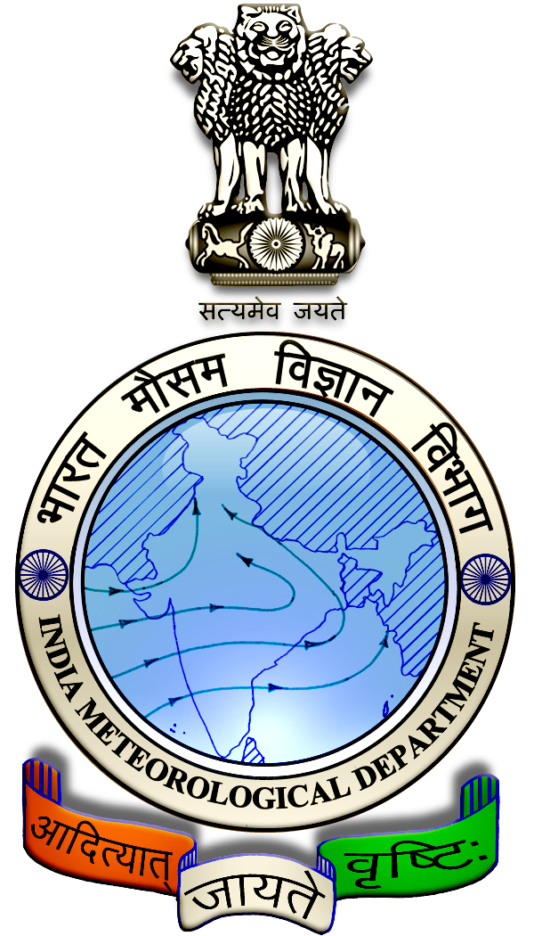
 | District : | Sivagangai | Forecast Period : | 11/09/2024 | to | 15/09/2024
 | Bulletine No : | MSSRF/SVG / 073/ 2024 | Release Date : | 10/09/2024

Significant past weather | From |  | 06/09/2024 | to | 09/09/2024
Parameters |  | Past Weather
Rainfall (mm) |  | 1.2
Maximum Temperature (ºC) |  | 39-41
Minimum Temperature (ºC) |  | 26-27
Sky Condition (Octas) |  | 5-6
Relative Humidity (%) |  | 42-65
Wind Speed (kmph) |  | 9-15

Ensemble Weather Forecast until | 08:30Hrs of | 15-09-2024
Parameters | 11-09-2024 | 12-09-2024 | 13-09-2024 | 14-09-2024 | 15-09-2024
Parameters | Wednesday | Thursday | Friday | Saturday | Sunday
Rainfall (mm) | 0 | 0 | 0 | 7 | 0
Maximum Temperature (°C) | 38 | 38 | 37 | 36 | 36
Minimum Temperature (°C) | 26 | 25 | 24 | 24 | 23
Sky Condition (Octas) | 4 | 6 | 7 | 8 | 8
Max. Relative Humidity (%) | 70 | 70 | 70 | 70 | 70
Min. Relative Humidity (%) | 40 | 40 | 40 | 40 | 40
Wind Speed (Kmph) | 14 | 12 | 10 | 8 | 10
Wind Direction | SW | SW | SW | SW | SW

SMS Advisory | Chances of light rain on 14 Sep. Maximum temperature would be in the range of 36℃ to 38℃ and the minimum temperature would be between 23℃ - 26℃. Generally cloudy sky will appear for the next five days. Wind is expected with the speed of 8 – 14 Kmph from, Southwest direction.

General Advisory:
Agriculture:
Farmers cultivating sugarcane and vegetables crops in rain-fed lands should provide rows and furrows at regular intervals and irrigate through furrows.

Irrigation water is economical as it is moistened only in the furrow area. Rain water drains easily if it gets stagnant in furrows.

In times of water scarcity, water can be saved by irrigating it with furrows. Intercropping is easy as the crops are arranged in rows.

Livestock:
Light to Moderate rain with thunderstorm and lightning is likely to occur at isolated places over district on 11 & 12 September 2024. Farmers are advised to take precautionary measures while grazing/herding the sheep, goat, cow on agriculture land for manuring purpose.

Do not allow the animals to graze outside, standing near the trees or electric poles. Provide safe shelter for your livestock.

Weather Based Agro-Advisories: (Onion, Mango & Animal Husbandry)
Onion:
The symptom of micronutrient (Zinc) deficiency is appearing in the Onion fields. Due to this deficiency, plant growth gets restricted. Leaves turn yellow in colour with strips and bend. To rectify this deficiency, foliar spray of 50gm of ZnSO4 twice at fortnight intervals is recommended.

Mango:
The incense of Grey Blight is expected in Mango. The symptoms of damage appear on leaves. Brown spots develop on the margin and at the tip of the leaf lamina. They increase in size and become dark brown.

To control this, spray Copper oxychloride @ 30 gm + Cartap hydro chloride @ 20gm + sticky agent @ 10ml with 10 litres of water.

Animal Husbandry:
Due to the prevailing weather, external parasites may attack your goats and sheep.

If symptoms are found, to protect your livestock from these external parasites, mix 2ml of Butox with one litre of water and apply the solution to the outer body of the sheep.

This medicine should not be used internally.

