 | AgroMet Advisory Bulletin (AAB)  Jointly released by  Regional Meteorology Centre, Chennai – India Meteorology Department,  Reddiarchathram Seed Growers Association &  M. S. Swaminathan Research Foundation, Kannivadi  Phone no.: 044 - 22541229 E mail: amfu.kanniwadi@gmail.com Fax: 044 – 22541319 |  |  |  |  |  | 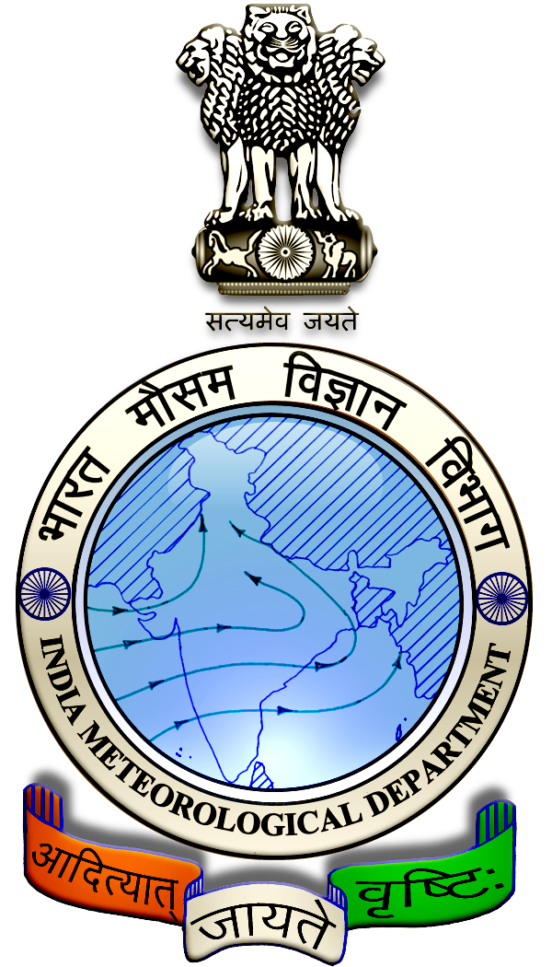
 | District : | Theni | Forecast Period : | 11/09/2024 | to | 15/09/2024
 | Bulletine No : | MSSRF/ THN/ 073/ 2024 | Release Date : | 10/09/2024

Significant past weather | From |  | 06/09/2024 | to | 09/09/2024
Parameters |  | Past Weather
Rainfall (mm) |  | 1.2
Maximum Temperature (ºC) |  | 39-41
Minimum Temperature (ºC) |  | 26-27
Sky Condition (Octas) |  | 5-6
Relative Humidity (%) |  | 42-65
Wind Speed (kmph) |  | 9-15

Ensemble Weather Forecast until | 08:30Hrs of | 15-09-2024
Parameters | 11-09-2024 | 12-09-2024 | 13-09-2024 | 14-09-2024 | 15-09-2024
Parameters | Wednesday | Thursday | Friday | Saturday | Sunday
Rainfall (mm) | 0 | 0 | 0 | 1 | 0
Maximum Temperature (°C) | 31 | 32 | 31 | 30 | 30
Minimum Temperature (°C) | 22 | 21 | 22 | 22 | 23
Sky Condition (Octas) | 4 | 6 | 7 | 8 | 8
Max. Relative Humidity (%) | 70 | 70 | 70 | 70 | 70
Min. Relative Humidity (%) | 40 | 40 | 40 | 40 | 40
Wind Speed (Kmph) | 14 | 12 | 12 | 14 | 12
Wind Direction | W | W | W | W | W

SMS Advisory | Chances of very light rain on 14 Sep. Maximum temperature would be in the range of 30℃ to 32℃ and the minimum temperature would be between 21℃ - 23℃. Generally cloudy sky will appear for the next five days. Wind is expected with the speed of 12 – 14 Kmph from, West direction.

General Advisory:
Agriculture:
Farmers cultivating sugarcane and vegetables crops in rain-fed lands should provide rows and furrows at regular intervals and irrigate through furrows.

Irrigation water is economical as it is moistened only in the furrow area. Rain water drains easily if it gets stagnant in furrows.

In times of water scarcity, water can be saved by irrigating it with furrows. Intercropping is easy as the crops are arranged in rows.

Livestock:
Light to Moderate rain with thunderstorm and lightning is likely to occur at isolated places over district on 11 & 12 September 2024. Farmers are advised to take precautionary measures while grazing/herding the sheep, goat, cow on agriculture land for manuring purpose.

Do not allow the animals to graze outside, standing near the trees or electric poles. Provide safe shelter for your livestock.
Weather Based Agro-Advisories: (Paddy, LabLab & Animal Husbandry)
Paddy:
The incense of Brown Spot disease expected in Paddy. The disease appears first as minute brown dots later becoming cylindrical or oval to circular on leaves. Spots coalesce to form large patches leading to the leaf drying up.

Infection also occurs on the panicle and neck with a brown color appearance.

To control spray Metominostrobin @ 500ml /acre.

LabLab:
The incidences of Pod bugs may be expected in the LabLab crop.

The Symptom of damage appears on pods, with black spots, shedding of green pods, and poorly filled pods with shrivelled grains inside.

To control spray the biocontrol agent, Beauveria bassiana @ 600gm per acre.

Animal Husbandry:
Due to the prevailing weather, external parasites may attack your goats and sheep.

If symptoms are found, to protect your livestock from these external parasites, mix 2ml of Butox with one litre of water and apply the solution to the outer body of the sheep.

This medicine should not be used internally.

