 | AgroMet Advisory Bulletin (AAB)  Jointly released by  Regional Meteorology Centre, Chennai – India Meteorology Department,  Reddiarchathram Seed Growers Association &  M. S. Swaminathan Research Foundation, Kannivadi  Phone no.: 044 - 22541229 E mail: amfu.kanniwadi@gmail.com Fax: 044 – 22541319 |  |  |  |  |  | 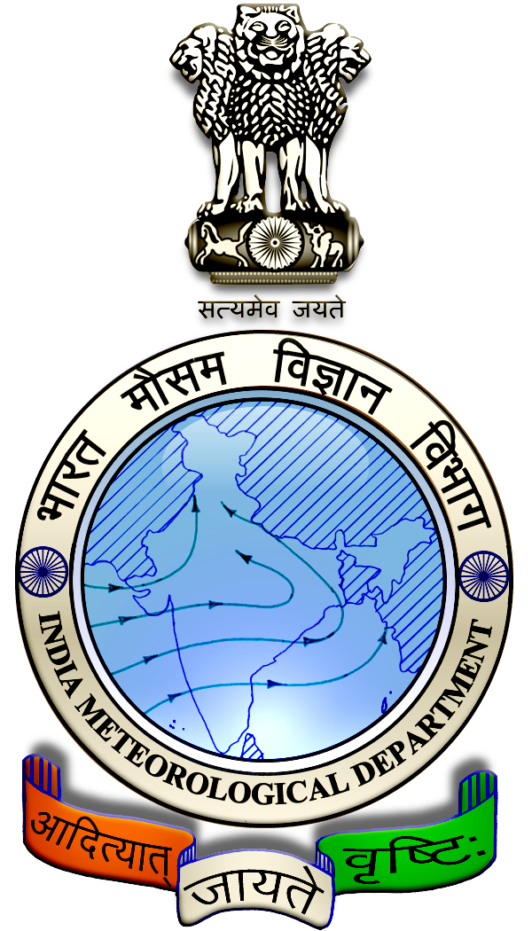
 | District : | Dindigul | Forecast Period : | 02/04/2025 | to | 06/04/2025
 | Bulletin No: | MSSRF/ DGL /026/ 2025 | Release Date : | 01/04/2025

Significant past weather | From |  | 28/03/2025 | to | 31/03/2025
Parameters |  | Past Weather
Rainfall (mm) |  | 0.0
Maximum Temperature (ºC) |  | 37-40
Minimum Temperature (ºC) |  | 23-26
Sky Condition (Octas) |  | 2-4
Relative Humidity (%) |  | 24-80
Wind Speed (kmph) |  | 7-13

Ensemble Weather Forecast until | 08:30Hrs of |  | 06-04-2025
Parameters | 02-04-2025 | 03-04-2025 |  | 04-04-2025 | 05-04-2025 | 06-04-2025
Parameters | Wednesday | Thursday |  | Friday | Saturday | Sunday
Rainfall (mm) | 0 | 9 |  | 33 | 31 | 27
Maximum Temperature (°C) | 37 | 37 |  | 36 | 35 | 34
Minimum Temperature (°C) | 26 | 24 |  | 23 | 22 | 22
Sky Condition (Octa) | 3 | 8 |  | 8 | 8 | 8
Max. Relative Humidity (%) | 80 | 80 |  | 80 | 80 | 80
Min. Relative Humidity (%) | 50 | 50 |  | 50 | 50 | 40
Wind Speed (Kmph) | 10 | 8 |  | 4 | 4 | 6
Wind Direction | SE | SE |  | W | SE | NW

SMS Advisory | Chances of Moderate rain during 3, 4, 5 & 6 Apr. Maximum temperature would be in the range of 34℃ to 37℃ and the minimum temperature would be between 22℃-26℃. Cloudy sky will appear for the next five days. Wind is expected with the speed of 4-10 Kmph from, Southeast, West & Northwest directions.

General Advisory:

Heavy rain is likely to occur at isolated places over the district during 4, 5 & 6 April 2025. Farmers are advised to act swiftly to repair the water channels, farm ponds and other water bodies to harvest the rain water. During these days farmers are advised to avoid irrigation, intercultural operations and application of plant protection measures to the standing crops, provide adequate drainage facilities in the fields to avoid water stagnation due to heavy rainfall, do not allow the animals to grazing outside, standing near the trees or electric poles & provide safe shelter.

THUNDERSTORM WARNING:

Thunderstorm with lightning is likely to occur at one or two places over district during 02. 04. 2025 to 06.04.2025. Keep your Livestock / Animals safely in the shelters. Don’t tie the animals to the electric poles and under trees.

To safeguard your animals from lightning and thunderstorm, remove the metal bells tied to the necks of animals.
Weather Based Agro-Advisories: Bhendi, Cluster beans & Animal Husbandry)
Bhendi:
The incense of Shoot and fruit borer were seen in Bhendi. Damages cause the terminal shoots to wither and droop, shedding buds and flowers, bore holes in fruits and feed and deformed fruits.
To manage this, collect and destroy the affected buds, flowers and fruits.
Setup pheromone trap @ 12 Nos. per hac.
To control spray 5 ml of Azadiractin or 500ml Neem extract concentrate with 10 litres of water.

Cluster beans:
The occurrence of Aphids noticed in Cluster beans. Nymphs and adults suck the sap of leaves.

It leads to leaf wilting, flower dropping and growth of the plants also hindered.

To control, spray Acephate @ 40gm + sticky agent @ 10ml with 10litres of water.

Fertilizer application and spraying activities should be carried out, only on non-rainy days.

Animal Husbandry:
Due to the hot weather conditions, the feed intake by chicks will be decreased, to rectify this increase the amount of amino acids, and mineral mixture with the chick feed.

During the summer season, the eggshells are also much thinner than usual. To avoid this, put a large amount of oyster on plates and always make it available for the layer birds.

The number of water tanks should be increased than usual (ie. 20% to 30%). To reduce the dehydration process, add more minerals to the water.

