 | AgroMet Advisory Bulletin (AAB)  Jointly released by  Regional Meteorology Centre, Chennai – India Meteorology Department,  Reddiarchathram Seed Growers Association &  M. S. Swaminathan Research Foundation, Kannivadi  Phone no.: 044 - 22541229 E mail: amfu.kanniwadi@gmail.com Fax: 044 – 22541319 |  |  |  |  |  | 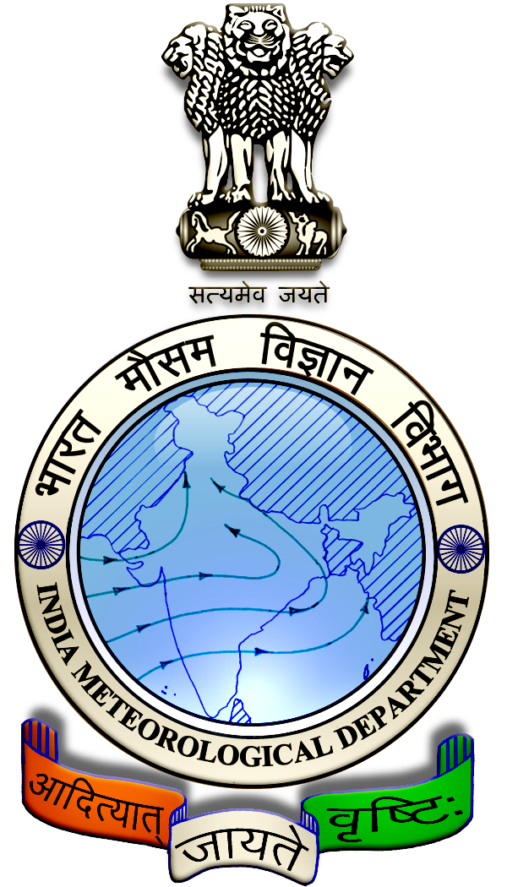
 | District : | Pudukkottai | Forecast Period : | 02/07/2025 | to | 06/07/2025
 | Bulletin No: | MSSRF/ PDK /052/ 2025 | Release Date : | 01/07/2025

Significant past weather | From |  | 27/06/2025 | to | 30/06/2025
Parameters |  | Past Weather
Rainfall (mm) |  | 11.4
Maximum Temperature (ºC) |  | 38-39
Minimum Temperature (ºC) |  | 27-28
Sky Condition (Octas) |  | 6
Relative Humidity (%) |  | 24-62
Wind Speed (kmph) |  | 20-31

Ensemble Weather Forecast until | 08:30Hrs of |  | 06-07-2025
Parameters | 02-07-2025 | 03-07-2025 |  | 04-07-2025 | 05-07-2025 | 06-07-2025
Parameters | Wednesday | Thursday |  | Friday | Saturday | Sunday
Rainfall (mm) | 1 | 2 |  | 4 | 4 | 1
Maximum Temperature (°C) | 37 | 37 |  | 37 | 38 | 38
Minimum Temperature (°C) | 27 | 27 |  | 27 | 28 | 28
Sky Condition (Octa) | 6 | 6 |  | 6 | 6 | 6
Max. Relative Humidity (%) | 60 | 60 |  | 60 | 55 | 55
Min. Relative Humidity (%) | 40 | 40 |  | 40 | 35 | 35
Wind Speed (Kmph) | 12 | 12 |  | 10 | 10 | 10
Wind Direction | W | SW |  | W | W | SW

SMS Advisory | Chances of light rain during 3, 4 & 5 Jul. Maximum temperature would be in the range of 37℃ to 38℃ and the minimum temperature would be between 27℃-28℃. Generally cloudy sky will appear for the next five days. Wind is expected with the speed of 10-12 Kmph from, West & Southwest directions.

General Advisory:
Extended range Forecast for next week (04th to 10th July 2025):
Rainfall:
As per extended range predictions, there is possibility generally below normal rainfall likely over the district during 04th to 10th July 2025.

Maximum Temperature:
Maximum temperatures are likely to be generally normal and are likely to be in the range 34°C to 38°C over the coastal of the district during next week. 04th to 10th July 2025.

Minimum Temperature:
Minimum temperatures are likely to be generally normal and are likely to be in the range 24°C to 28°C over the coastal of the district during next week 04th to 10th July 2025.

Agriculture:
Due to hot and humid conditions, discomfort weather is likely at isolated pockets over the district during next Two days (02.07.2025 & 03.07.2025). Hence farmers are advised to plan their field activities during morning and evening hours and avoid working in the field during 12 noon to 4 Pm. Stay safe and take care. Drink adequate water.

There is a rise in maximum temperature for the forthcoming days, and due to this the soil moisture content may be reduced.

Based on the soil moisture condition of the field, farmers can provide irrigation to their crops.

Farmers are advised to take up mulching around the root basin of the horticulture crop with dried leaves, grass and other farm wastes to retain the soil moisture content.

Weather Based Agro-Advisories: (Banana, Paddy, Brinjal & Animal Husbandry)
Banana:
Farmers who have planted banana should apply 20gm each of Azospirillum and Phosphobacteria per plant at the growing stage, once at one month after planting and again after 5 months after planting.

Paddy:
Kind attention to Paddy cultivators, paddy crops are prone to the attack of sap sucking insects due to high humidity in the air. Spray Azadirachtin @ 2ml/litre of water with sticking paste, to control thrips and sap sucking insects.

Brinjal:
This season is suitable for vegetable seed sowing. Farmers are advised to treat the vegetable seeds with Trichoderma viride @ 10gm/ kg of seed before sowing, to avoid rot disease in seedlings.

Animal Husbandry:
Farmers are advised to feed greens and straw to the milking cow in 50:50 ratios, as half quantity in the morning and half in the evening after milking.

Do not change the fodder and its quantity, it can be changed gradually.

Long and hard stem fodders should be cut into small pieces before feeding the Cow.

Better to feed the cow with a mixture of young foliage and dry grass with hay.

Silage should be given after the milking. Concentrate feeds should be given in the morning and evening hours with equal distribution.

